SCLERA - ASMOTOM

Automated Trephine System for harvesting corneo-scleral discs from a donor

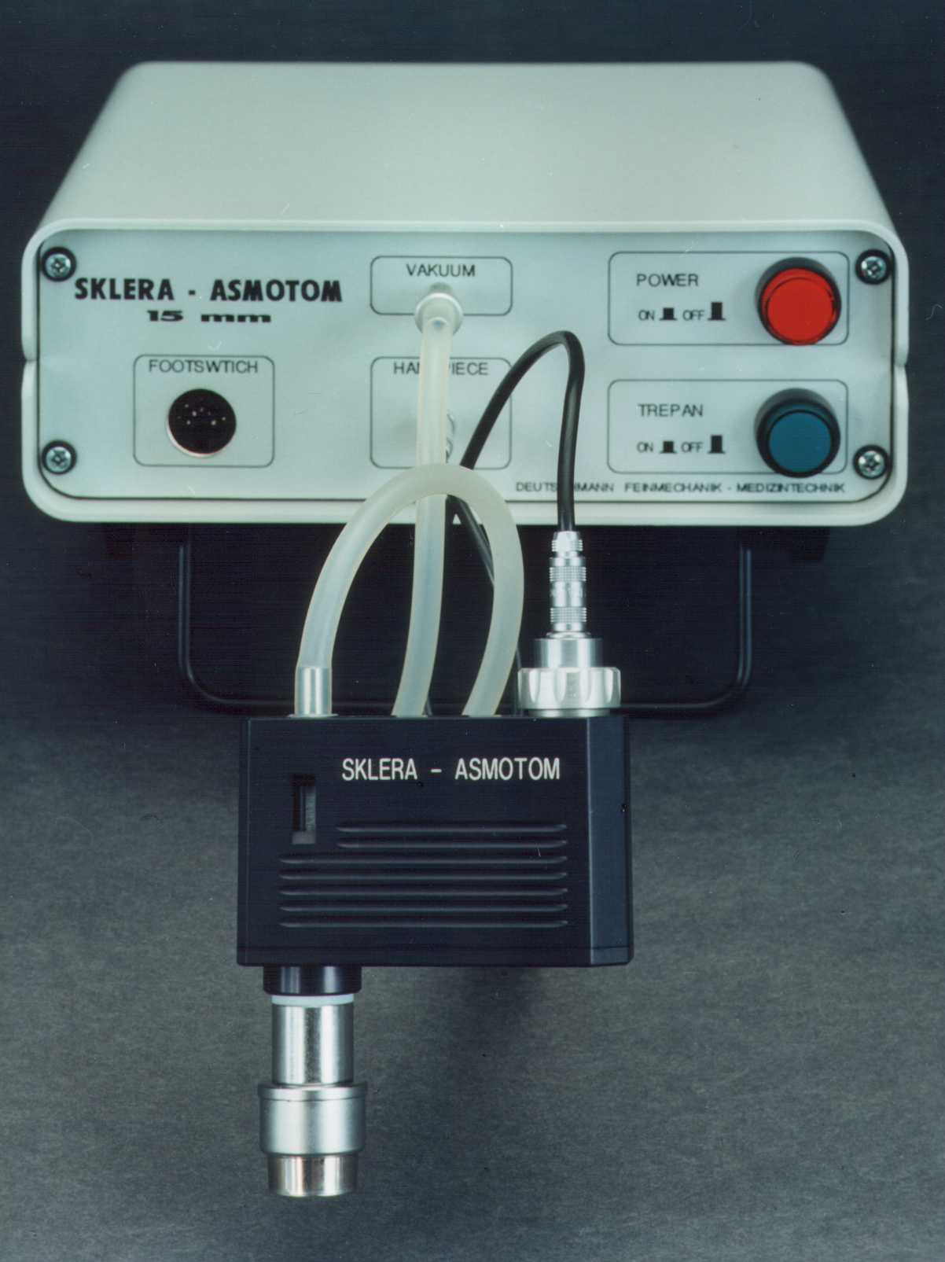
The main components are the control unit and the hand piece set.

The control unit contains a vacuum pump, and a NiCad rechargeable battery pack. This allows a mobile use of the system.

The trephine hand piece is composed of a central circular suction bell and a concentric circular trephine blade. The suction bell holds the corneo-scleral structure of the donor during the automatic trephination process.

A removable motor cartridge in the hand piece drives the trephine blade. An automatic cutter feed mechanism slowly advances the rotating blade into the sclera, until the final cutting depth is reached. The cutter then retracts into its initial position. The separated corneo-scleral disc is still attached to the suction bell. After turning the vacuum switch off, the disc can easily be removed for further processing.

The trephination cycle can be activated in two ways:
- By the trephine switch on the control panel or
- By using the footswitch.

All mechanical components of the trephine hand piece are laid out on an organized sterilizing tray, which is contained in a sterilizer case. The case is also the primary storage of the components. There is additional space provided on the tray to hold optional instruments. (Instruments not included!)

The complete system is contained in a carrying case, which holds the control unit, the sterilizer case containing the trephine, the footswitch and the motor cartridge, which is stored in a box.

A power cord and charger completes the system.

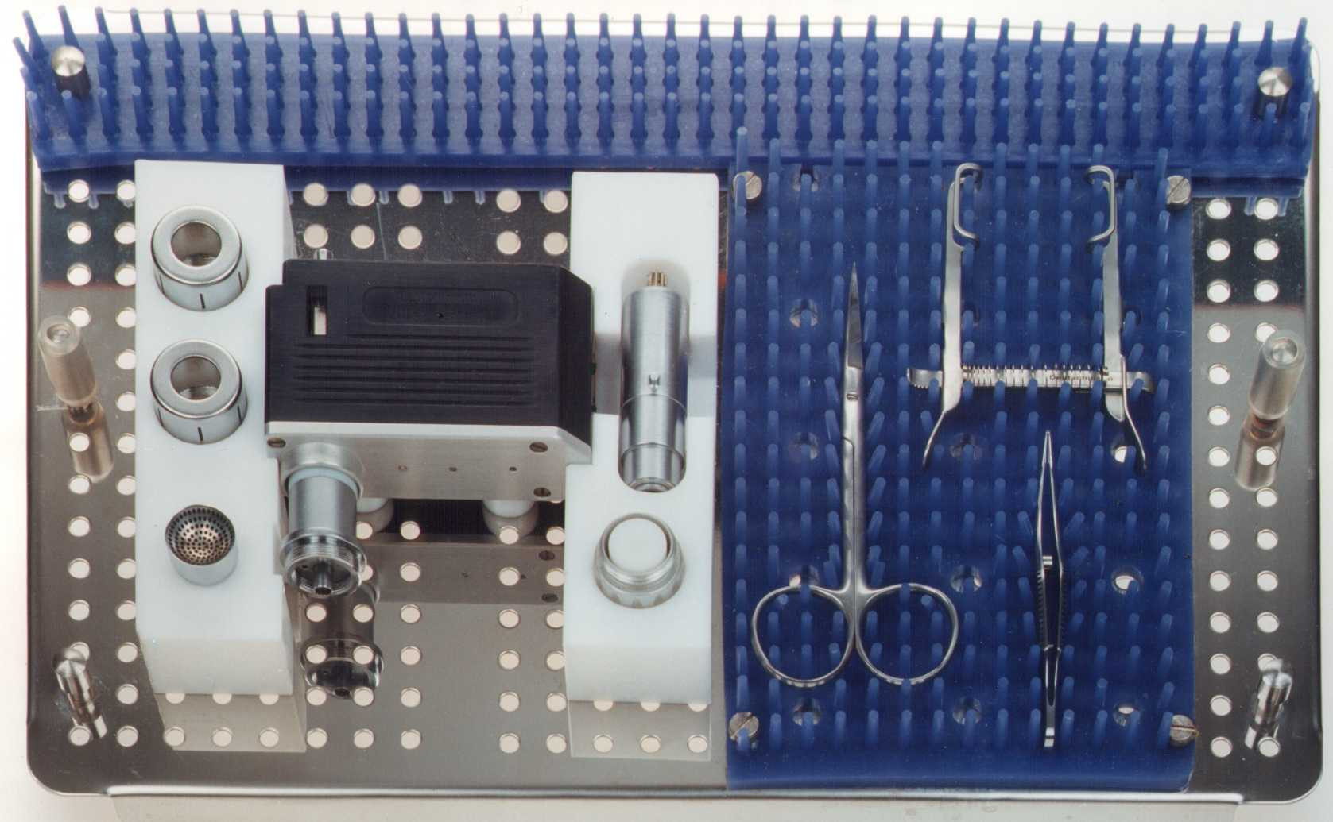
The Sclera ASMOTOM consists of the following elements:

1 Control unit
- 1 Trephine hand piece
- 2 Trephine blades (16 mm DIA)
- 1 Suction bell
- 1 Motor holding nut

1 Motor cartridge
- 1 Footswitch
- 1 Charger
- 1 Charger power cord
- 1 Users manual
- 1 Charger manual
- 1 Transport case

Distributed by GENERAL INNOVATIONS

7334 Hollister Avenue Suite i

Goleta, CA 93117 USA
Phone: +1 (805) 685-9991 Fax: +1 (805) 685-1292
Visit us at: WWW.generaltrade.net, or E-mail us to: gimsg@earthlink.net

