Users Manual

ASMOTOM

Automated Trephine System
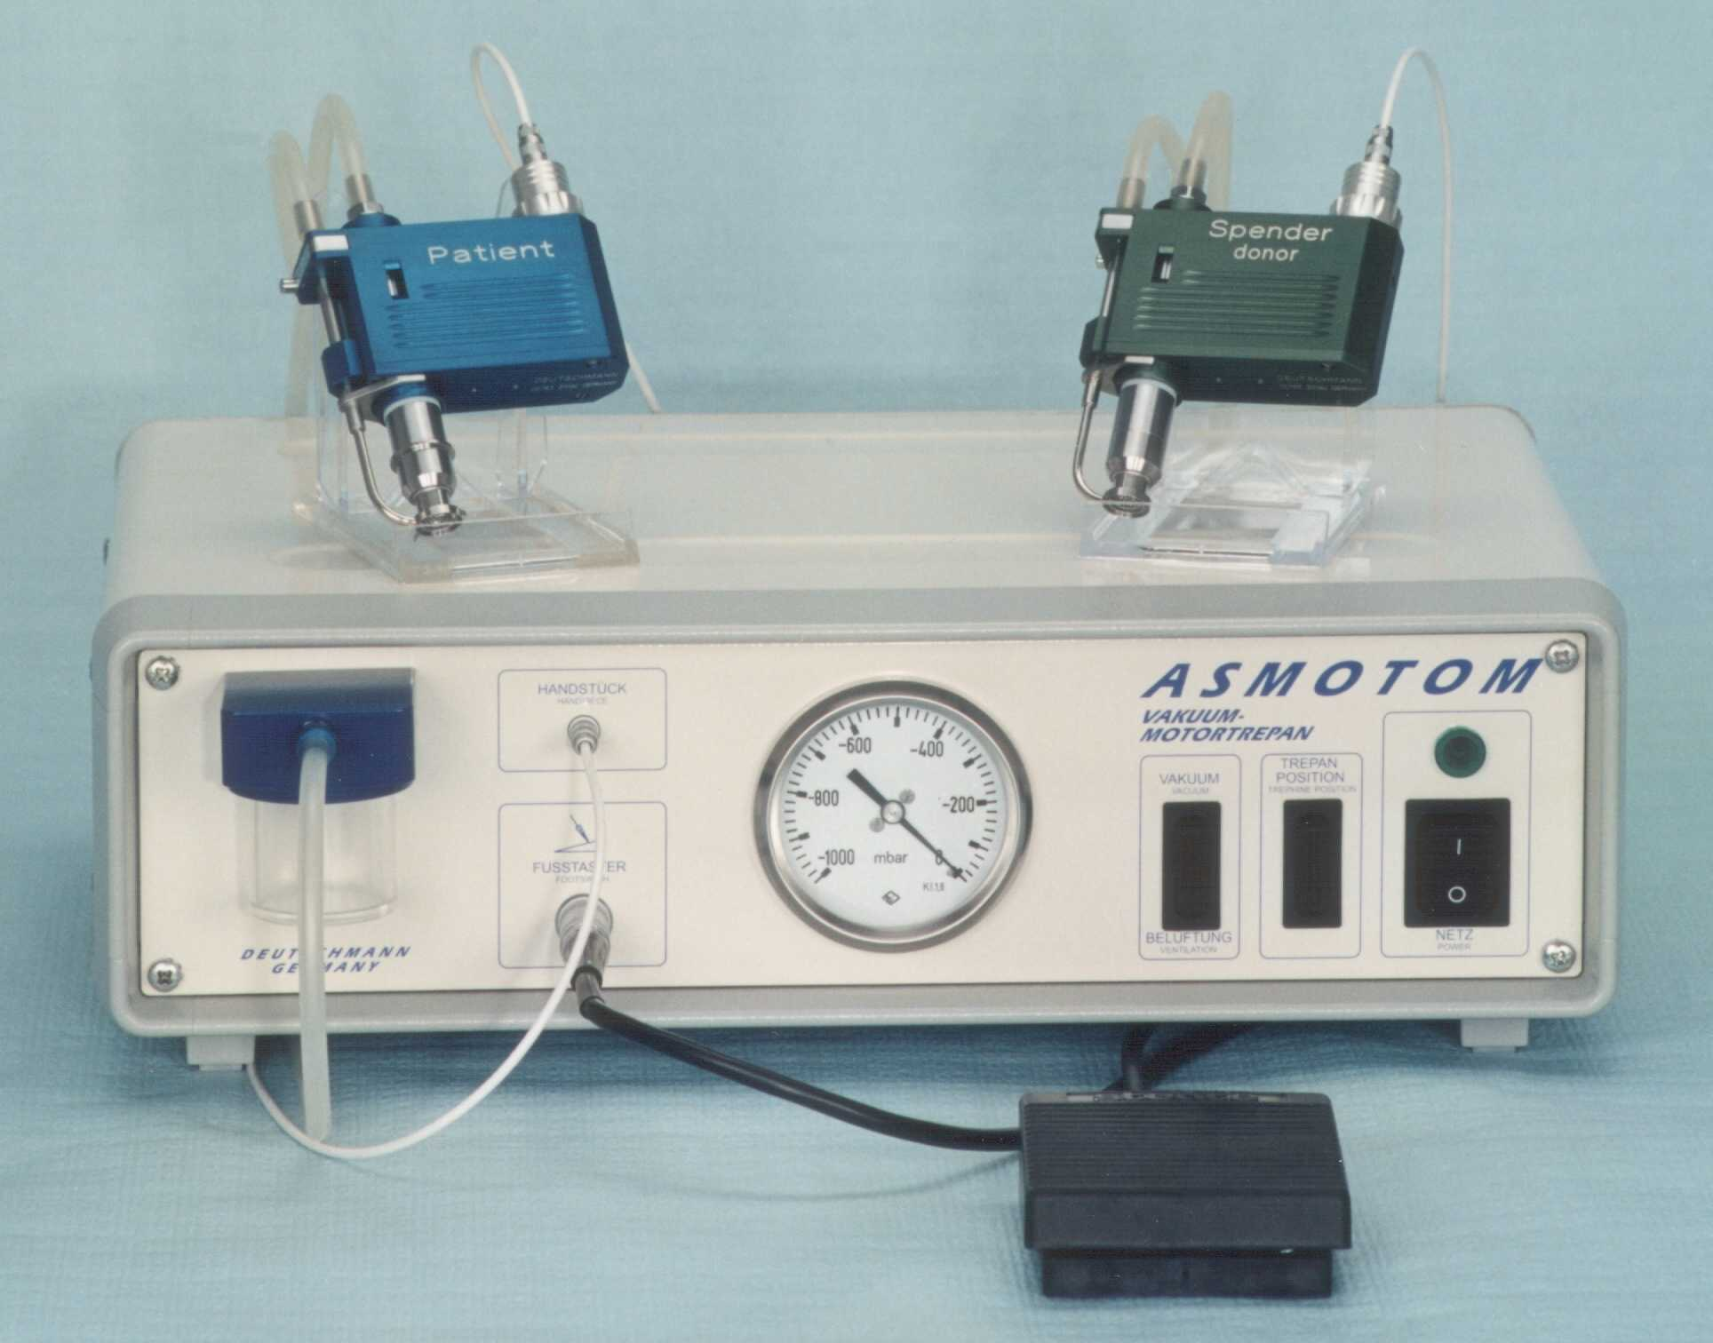
Manufactured By:
Deutschmann Instruments
Zittau - Germany

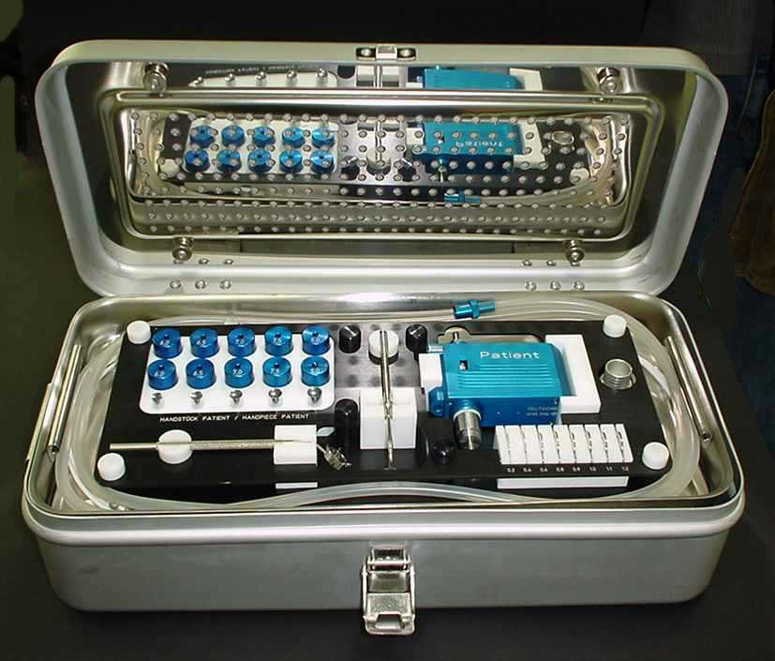

The Patient and Donor Instrument sets are contained in a sterilization cassette on individual trays
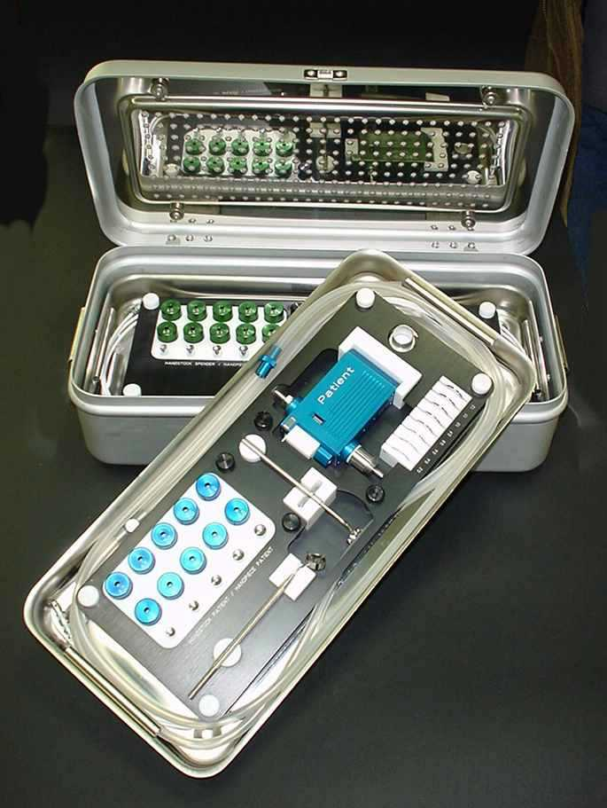

The ASMOTOM ATS (Automated Trephine System) - Users Manual

The ASMOTOM ATS consists of the following main components:

Control Unit - This is an electronic box containing a power supply, a vacuum pump, electronic circuitry, control switches, connectors and a vacuum gauge.

Sterilizer box - This is the storage case for the instrumentation. It has two trays. Each tray contains a complete set of instrumentation necessary for trephination. One tray is dedicated to the PATIENT, the other to the DONOR.

Accessories - These are the remaining three loose items. They are the power cord, footswitch and a small case containing the two miniature motor cartridges.

IMPORTANT!

Please read this manual carefully before assembling the ASMOTOM.

This system consists of high precision mechanical parts, which are sensitive to shock, moisture, temperature and chemicals.

This device requires careful, delicate handling by experienced personnel.

Please be gentle and pay attention, when assembling, disassembling, cleaning, disinfecting and handling any of the components.

When the unit is not in use, store all components in the original storage trays.

Only use parts from the original manufacturer.

Warning!

Never sterilize the engine cartridges! - It will destroy them.

Do not lubricate any part of the system. All parts are designed to use combinations of materials, which do not require lubrication.

We will not be responsible for damages to the unit, which result from improper use, abuse, mishandling or accidents.

Deutschmann Instruments reserves the right to make changes to any part, assembly or system – with the intent to further improve the design.

Table of contents Page

- Contraindications 5
- Safety Instructions 5
- Introduction to the ASMOTOM ATS 5
3. The ASMOTOM ATS and its controls 6, 7, 8
- Preparing the control unit for use 8
- Preparation and assembly of the PATIENT and DONOR hand pieces 9
- Initialization of the hand pieces 11
- Trephination 11
7.1. Trephination of the transplant from a corneo-scleral disc 11
- 7.2. Trephination on the patient 11
7.2.1. Preparation of the patient 12
7.2.2. Centering the trephine 12
    - Trephination of the patient cornea 12
8. Disassembly and preparation for cleaning and sterilization 13
9. Disinfecting, cleaning, and sterilization 13
  - Motor cartridges for patient and donor 13
  - Hand pieces for PATIENT and DONOR 14
  - Trephine blades for PATIENT and DONOR 14
  - Suction bell and Suction ring for PATIENT and DONOR 14
  - Offset rings – PATIENT only 14
  - Cables, hoses, and liquid container 15
  - Hand piece power cables 15
  - Liquid container 15
  - Sterilization 15
10. Troubleshooting 16
11. Technical data 17
12. Service of the ASMOTOM Automated Trephine System 18

Appendix A – Cleaning solution “Elma Clean”
Description, Application and dosage, Safety warnings 19
Physico-chemical facts, Disposal, Volumes and Storage 20

0. Contraindications

The ASMOTOM ATS should not be used if one of the following conditions exist:

- Pathologically thickened cornea, where the maximum cutting depth of 1.2 mm may not be enough. Do not use more than one offset ring – the travel depth may be insufficient!
- In case of an extremely thin or irregular cornea.
(Should the ASMOTOM ATS be used in such a case, the cut should be terminated by releasing the foot switch, after the first perforation - and finished manually with a pair of keratoplastic scissors.)

1. Safety Instructions

- IMPORTANT! Read the operating manual carefully prior to using the ASMOTOM. Follow all instructions.
- Warning! The ASMOTOM is not clean and not sterile upon delivery! It may cause infection and adverse reactions. Prior to the first surgical use, clean, disinfect and sterilize both hand pieces, all their parts and accessories thoroughly.
- Warning! Do not use the ASMOTOM if the power cord is damaged. It could cause death by electrical shock! Replace immediately!
- Warning! The ASMOTOM will not function properly outside its operational temperature range, potentially causing harm to the patient! It should only be used at ambient temperatures between 10°- 40°C.
- Warning! If for any reason the safe operation ASMOTOM is in doubt, it has to be turned off and locked away to prevent it to be used accidentally!
- Warning! Make sure that the cutter feed is in the home position on both hand pieces before use. If not, the cutter may be in an advanced position, where it may injure the cornea or transplant. Follow chapter 6 to re-home the cutter.
- Warning! Never use a damaged trephine! It can cause injury to the patient. Exchange it for a new one.
- Warning! Always use one and only one offset ring for depth adjustment on the patient hand piece to avoid unpredictable cutting depth settings, and thereby injuring the patient.
- Warning! Never use damaged, deformed or bent offset rings. They may cause injury to the patient! Exchange them for new ones.
- Warning! During assembly make sure that the central vacuum bell and trephine blades are screwed in all the way. Improperly assembled hand pieces can cause injury to the patient.
- Warning! Attach the liquid container to the liquid separator properly, to avoid vacuum leakage.
- Important! Always perform a dry run with both, the patient and donor hand pieces prior to their use on the patient or transplant, to make sure the equipment is fully operational.
- Caution! Do not expose the motor cartridges to moisture! Do not wash them! Do not place them in ultrasound cleaners! Do not sterilize them! Do not lubricate them!

2. Introduction to the ASMOTOM Automated Trephine System
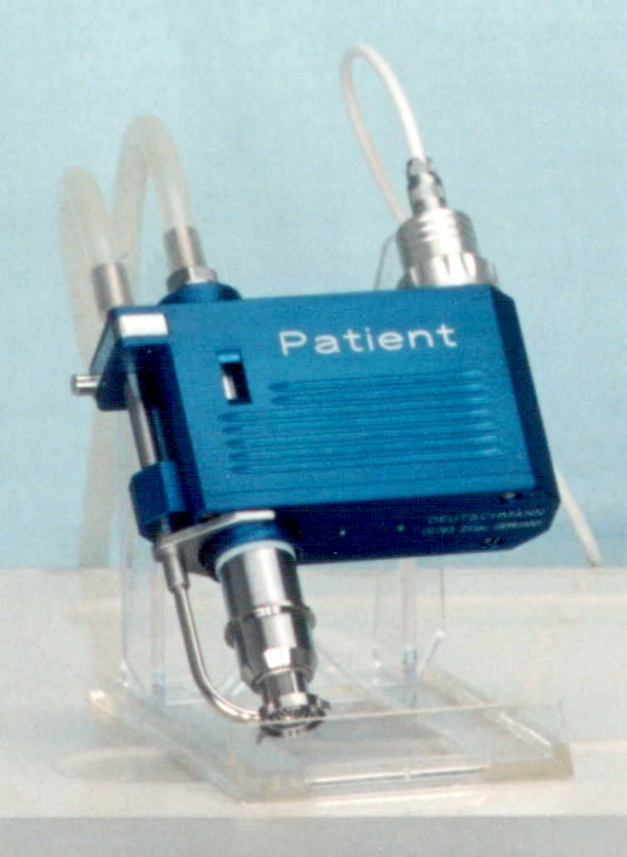

The ASMOTOM ATS offers a great advantage during trephination due to its double vacuum fixation system and automation. It holds on to both sides of the circular cutter. Inside it attaches to the central portion of the cornea with its suction bell, and outside to the peripheral portion of the cornea, along the limbus, with a suction ring.

The Trephine rotates between the both fixation zones. It advances into the cut using a cutter feeding mechanism, and retracts into its initial position, once the preset depth is reached, holding on to the separated central corneal section until the vacuum is turned off.

The cutting depth can be pre-set on the patient hand piece using one of the supplied offset rings.

- The components of the ASMOTOM ATS

Front view of the ASMOTOM control unit:

5
6
8
9
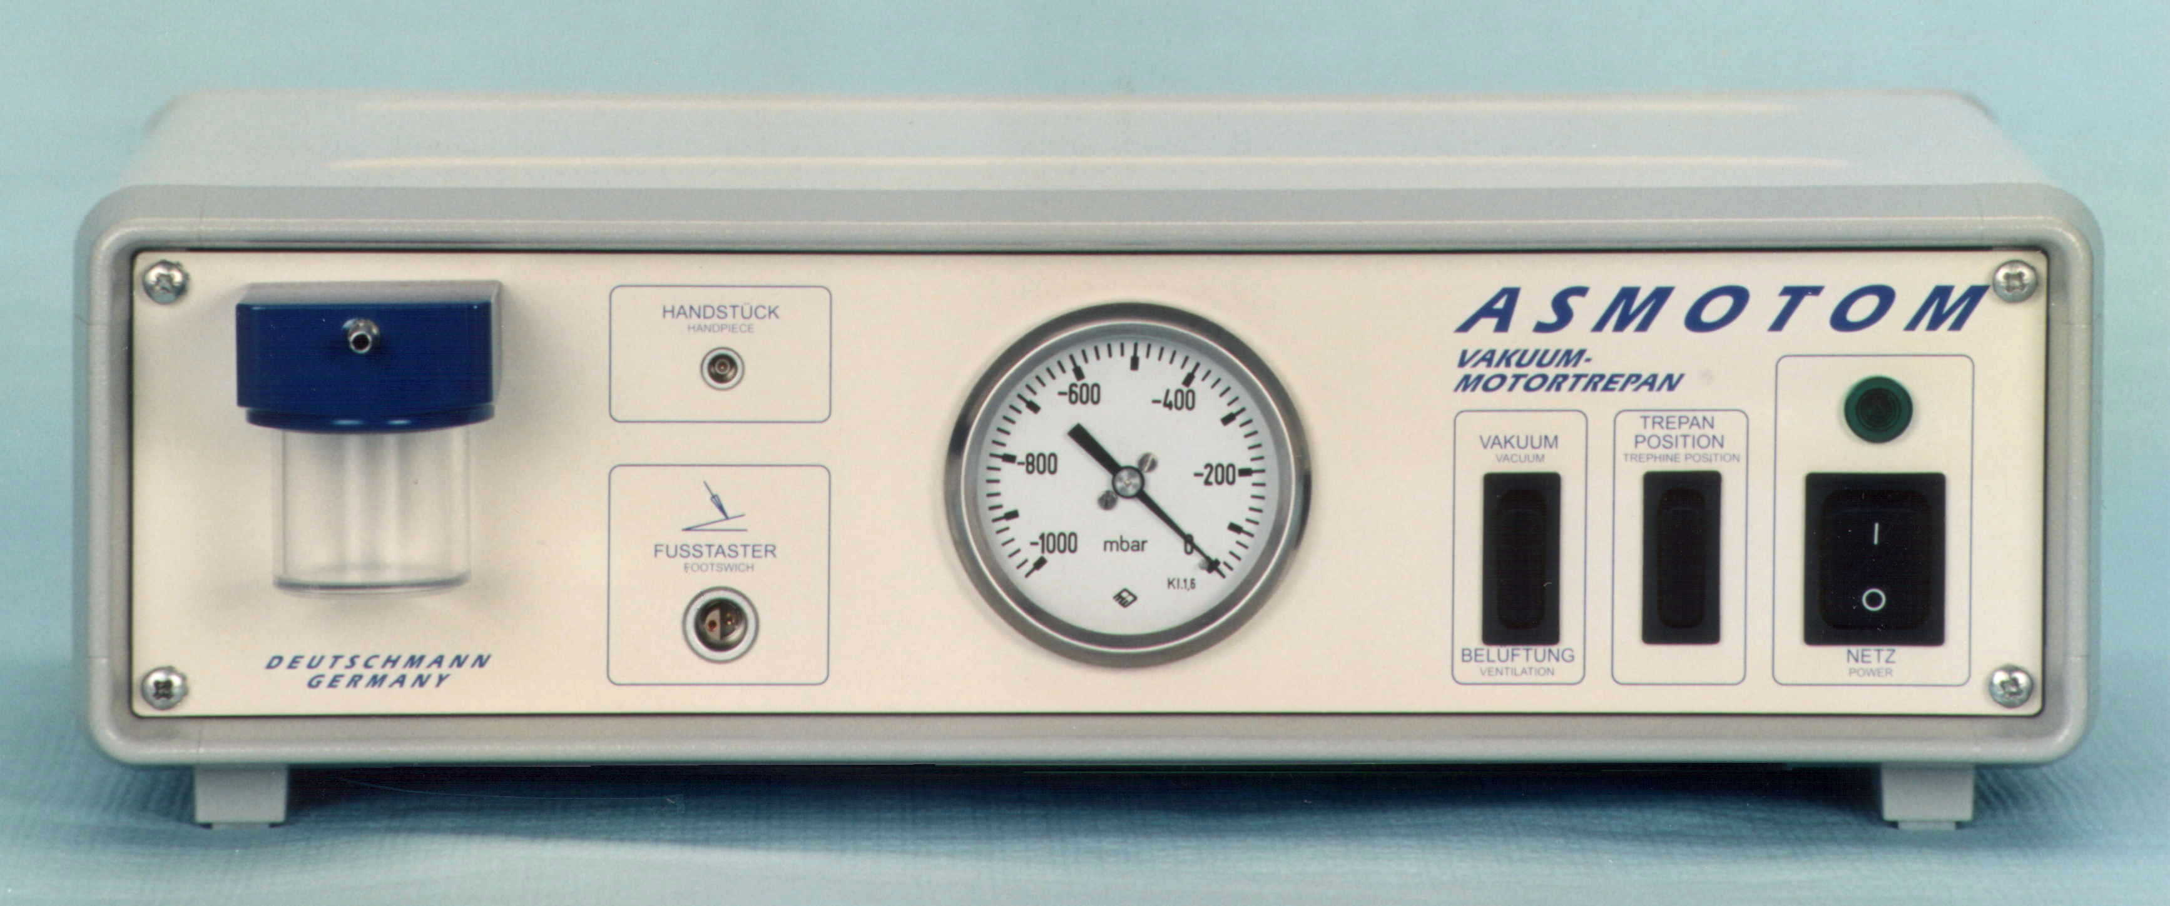

1

2
3
4
7
10

- Power ON light
- Power switch
- Trephine blade feed homing switch
- Vacuum switch
- Pressure gauge (in mbar)

- Connector for hand piece motor cartridge
- Foot switch connector
- Vacuum connector for hand piece
- Liquid separator
- Container for separated liquid

Rear view of the ASMOTOM control unit
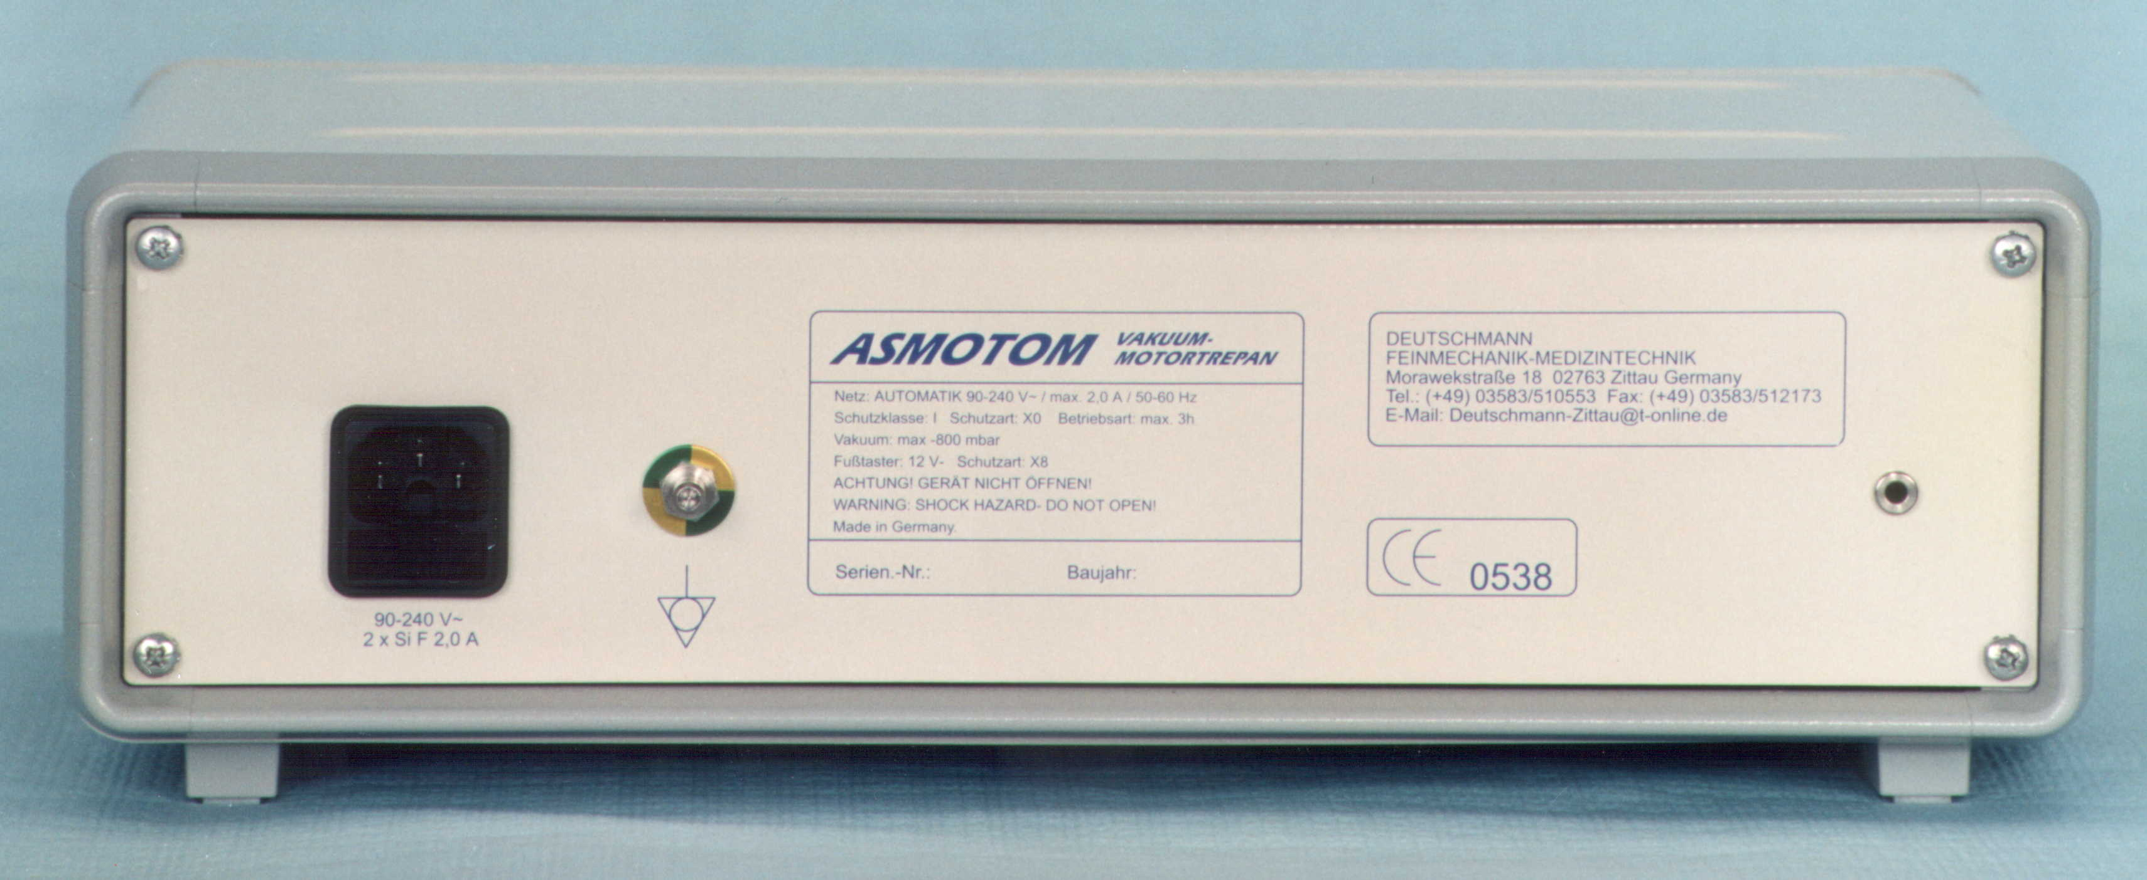

11

12
13
14
15

- Power connector
- Fuse
- Ground connector

- Equipment placard
- Breather

PATIENT hand piece - Storage and sterilization tray
16
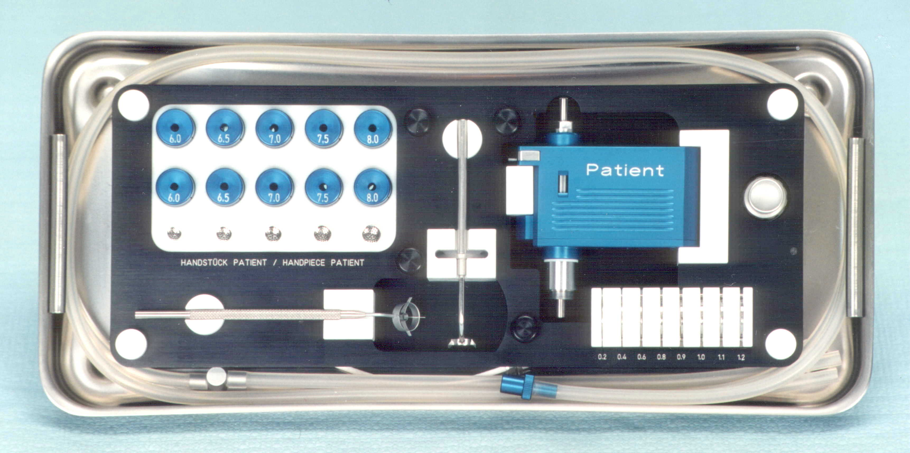
17
18
19
20

21
22
- Trephine cutters, diameters:
6.0, 6.5, 7.0, 7.5, and 8.0mm
- Central suction bell
- Peripheral suction ring assembly

- Patient hand piece
- Motor cartridge securing nut
- Offset rings for depth adjustment
- Corneal marking tool

Donor hand piece - Storage and sterilization tray

24
23
25
27
26
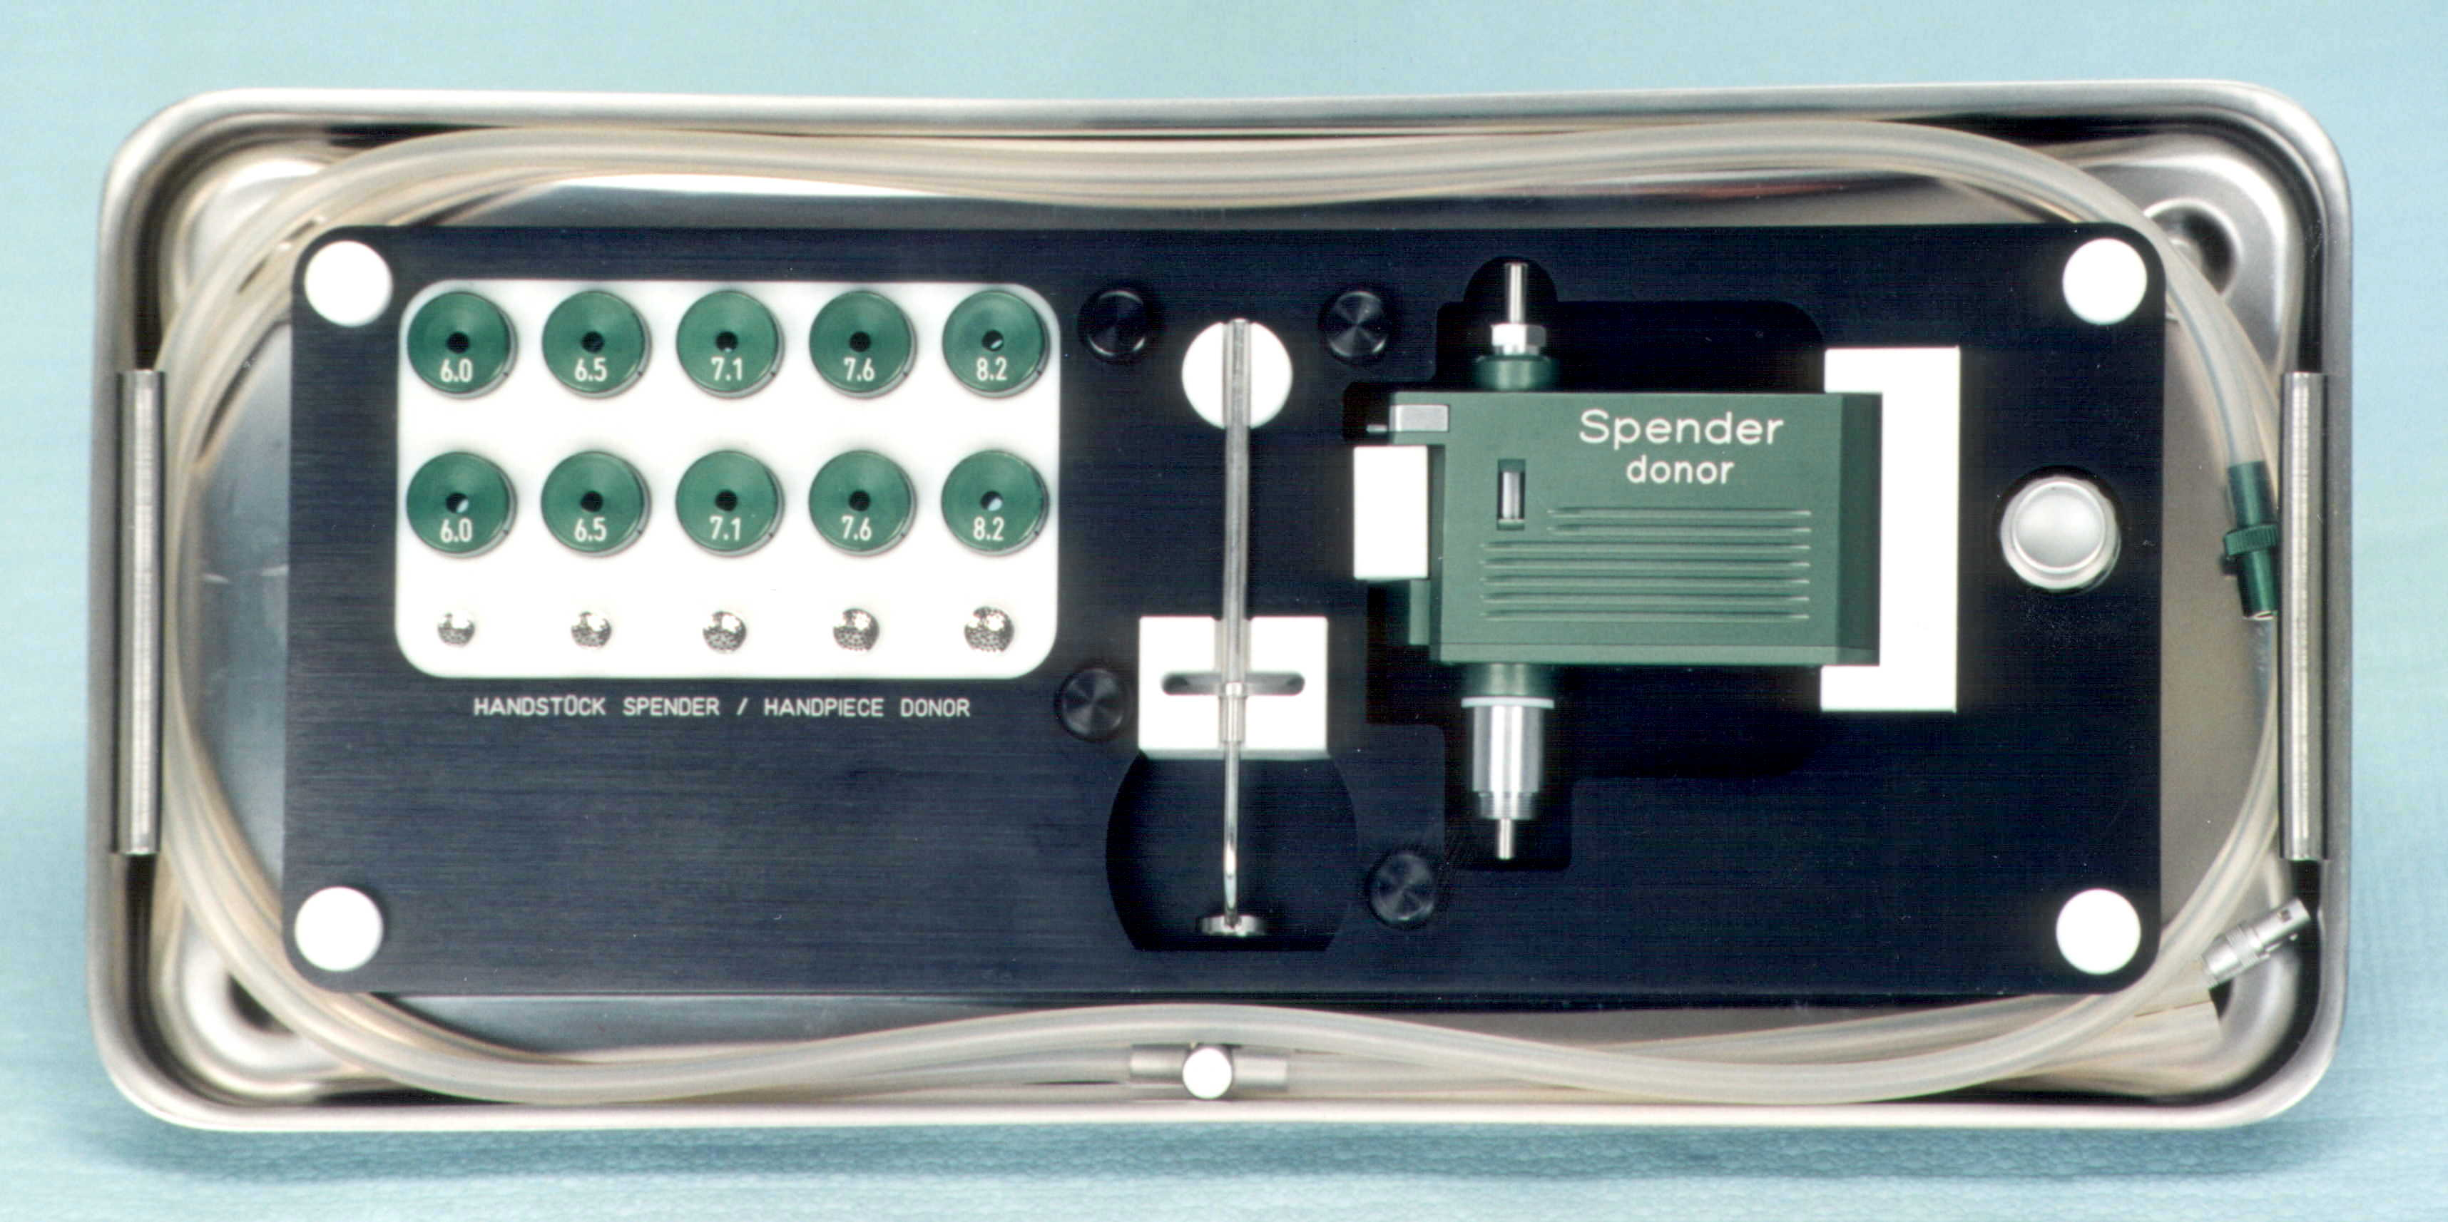

- Trephine cutters, diameters:
6.0, 6.5,7.1, 7.6, 8.2mm
- Central suction bell

- Peripheral suction ring assembly
- Donor hand piece
- Motor cartridge securing nut

Accessories

29
32
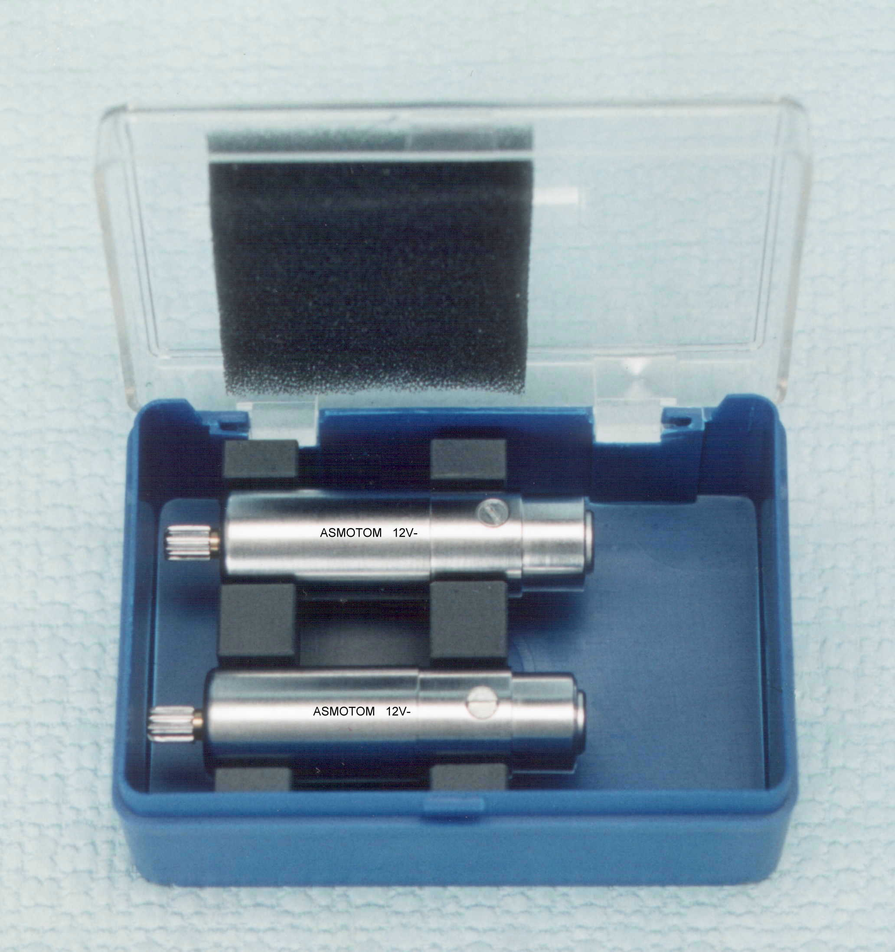
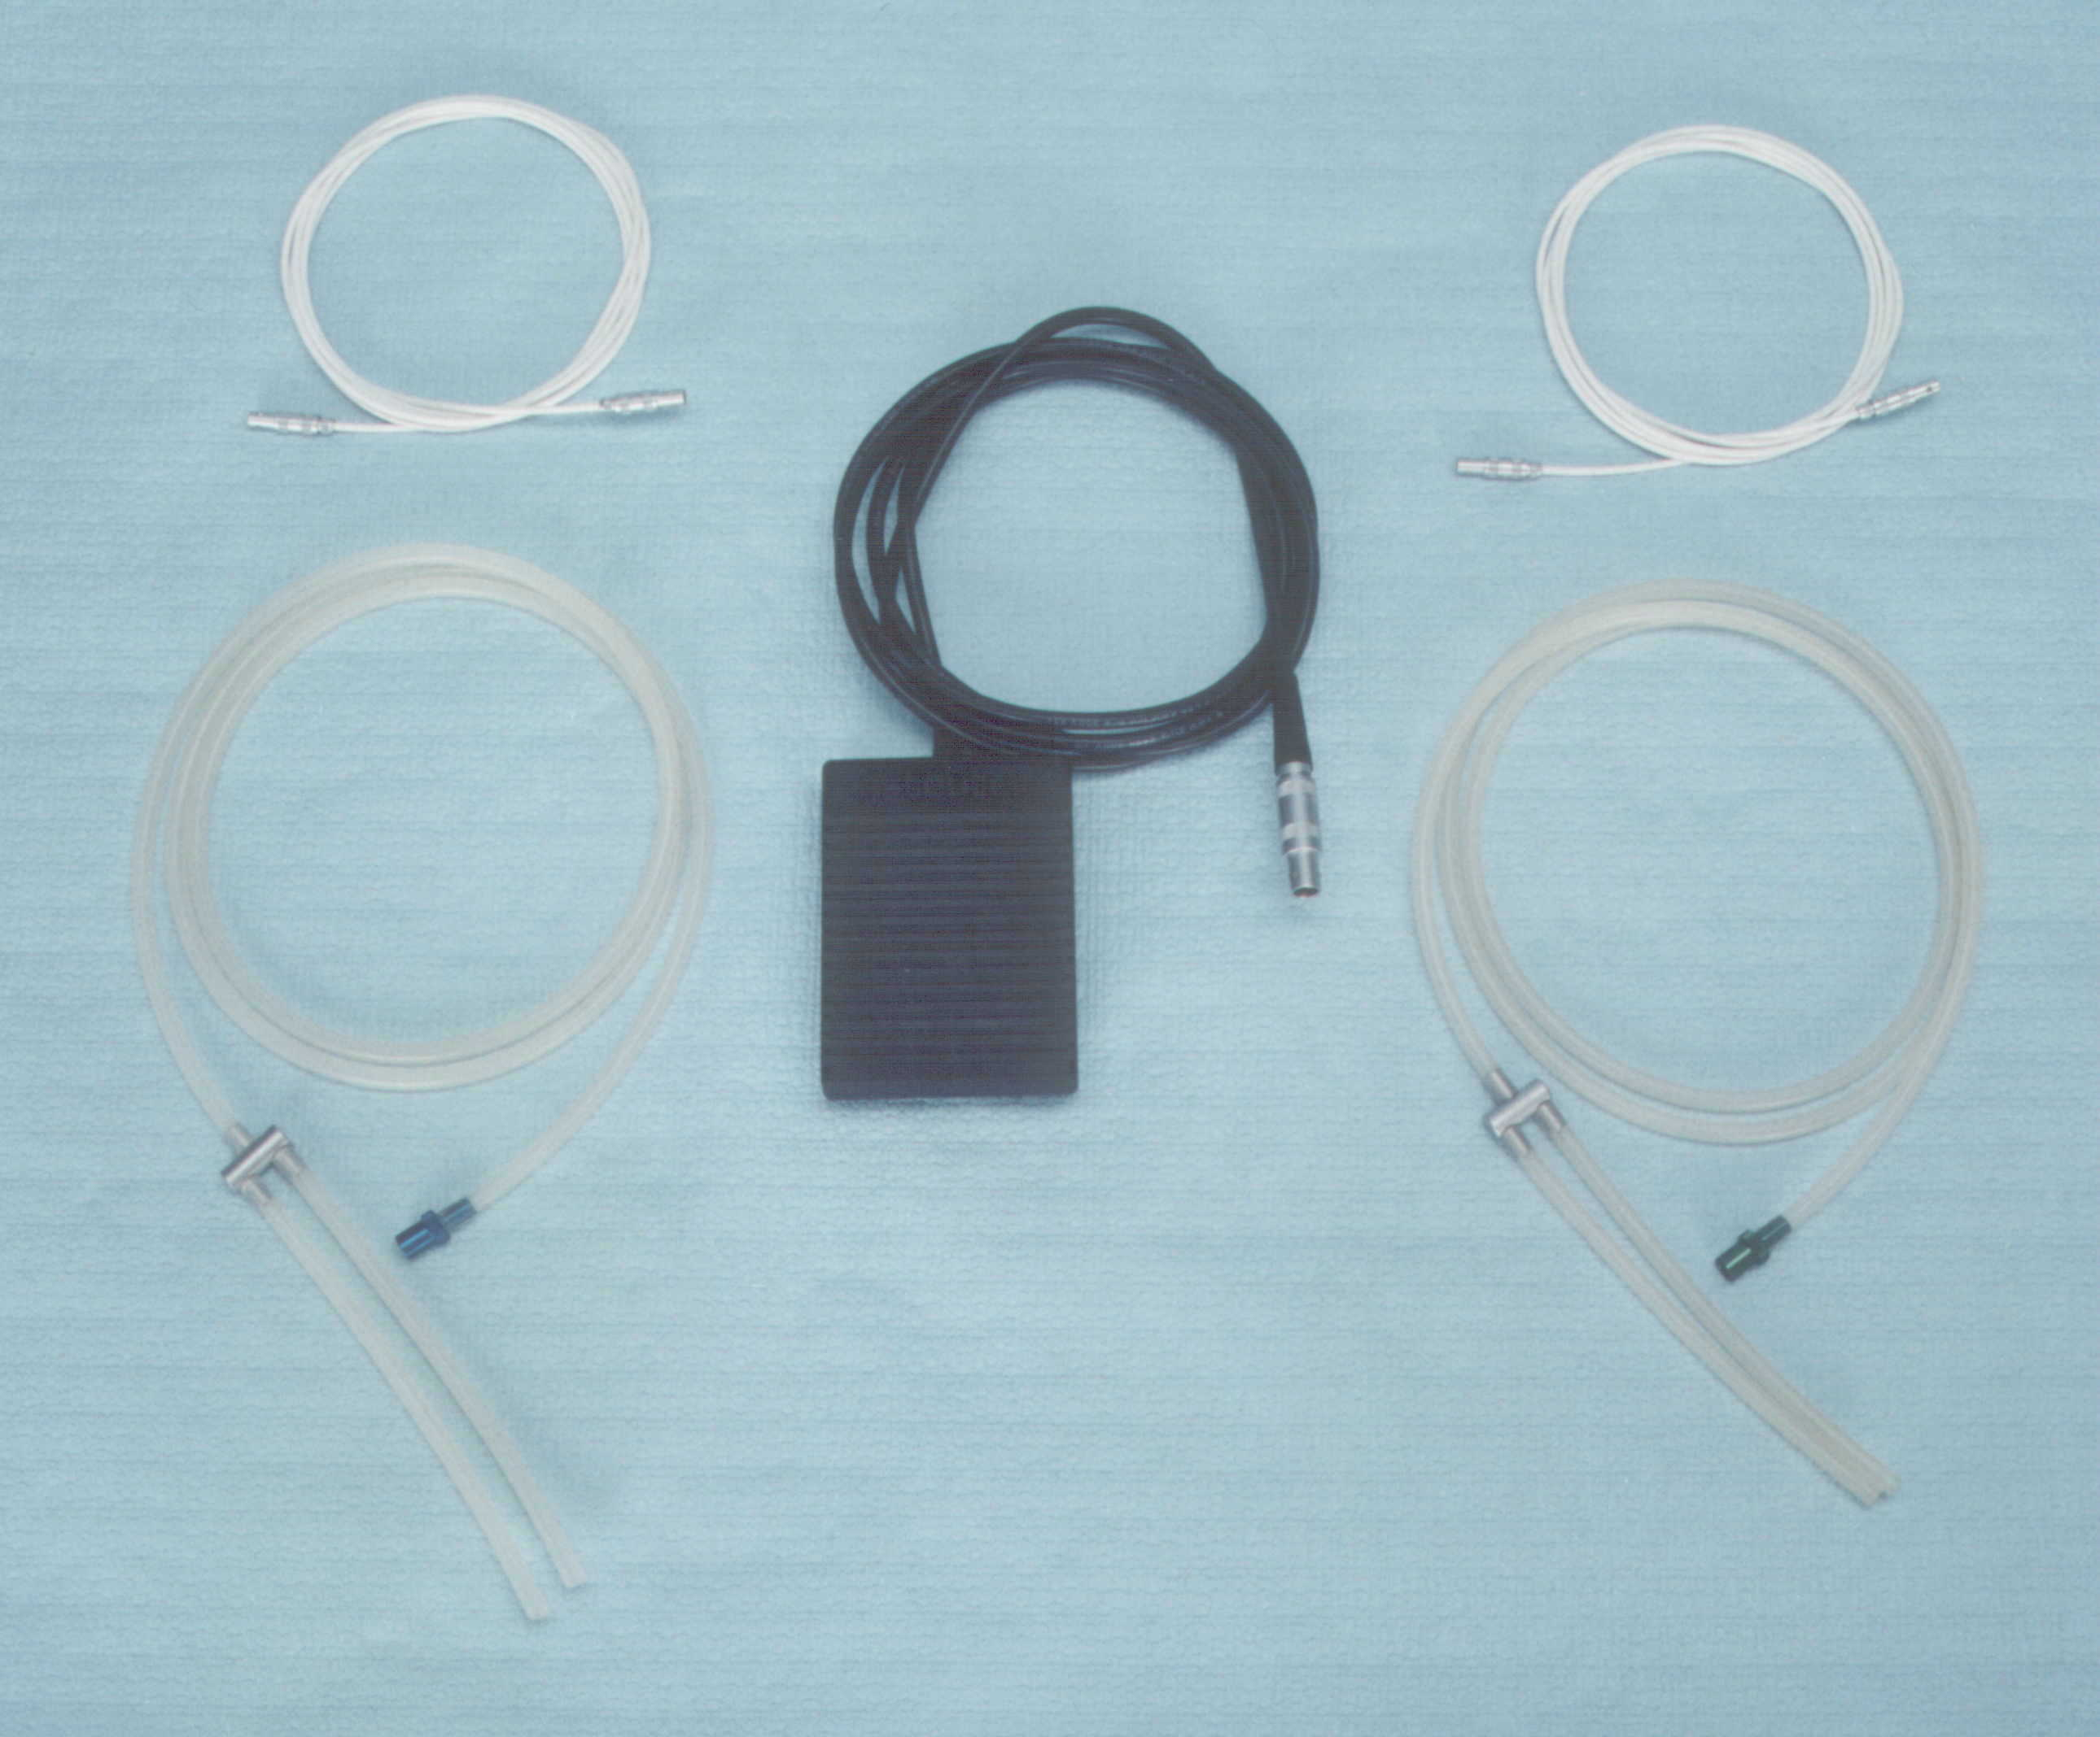

30

33

28
31
34

- Vacuum hose – PATIENT – blue connector
- Motor cartridge power cable - PATIENT hand piece
- Motor cartridge - PATIENT blue
- Vacuum hose – DONOR – green connector

- Motor cartridge power cable - DONOR hand piece
- Motor cartridge - DONOR green
- Footswitch

4. Preparing the control unit for use

- Please make sure that the power switch (2) is in the OFF position and the vacuum switch (4) is on.
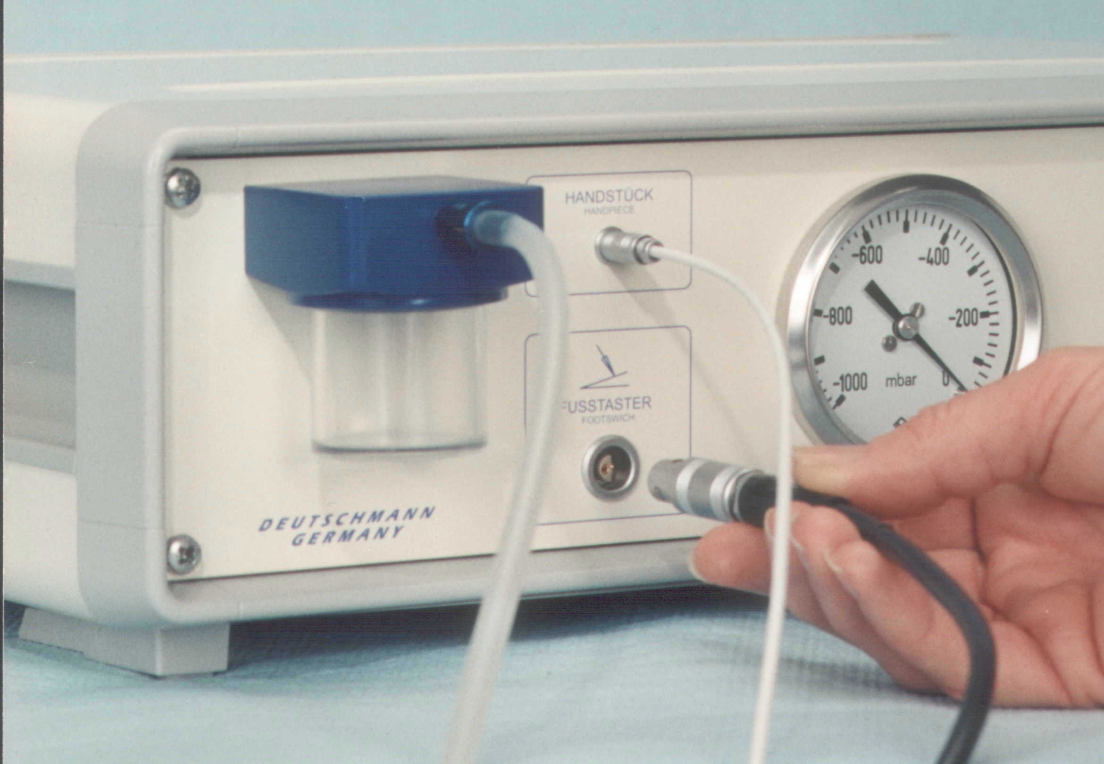
- The ASMOTOM has to be grounded to the common ground of the surgical theatre, using ground connector (13).
- Connect control unit power connector (11) to power outlet using power cord.
- Connect footswitch into connector (34)
- Connect hand piece power cable (29/32) into connector for hand piece (6)
- Connect liquid container (for separated liquid - 10) by screwing it into liquid separator (9)
- Connect hand piece vacuum hose (28/31) via Luer connector to vacuum connector for hand piece on control unit (8) (Luer connector blue = PATIENT, green = DONOR)

Now the control unit is ready for operation.

- Preparation and assembly of the PATIENT and DONOR hand pieces

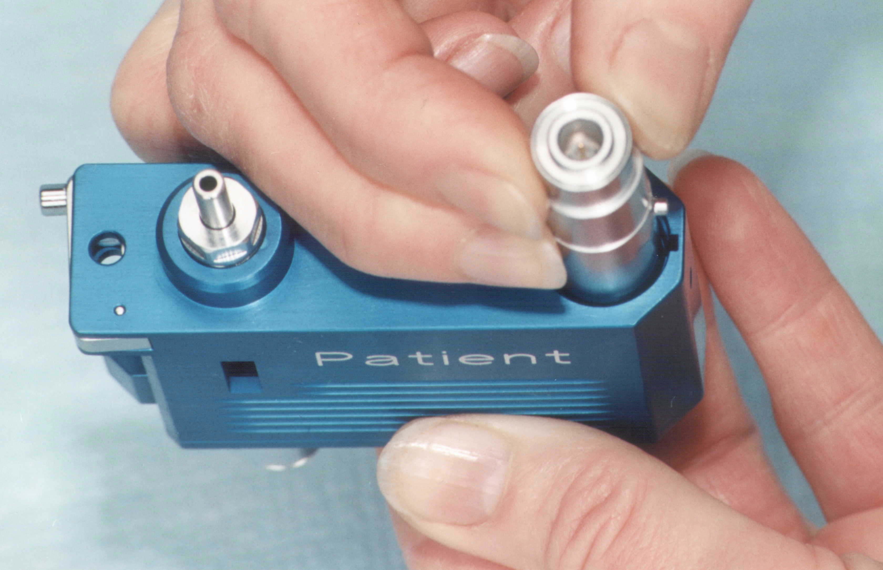 | 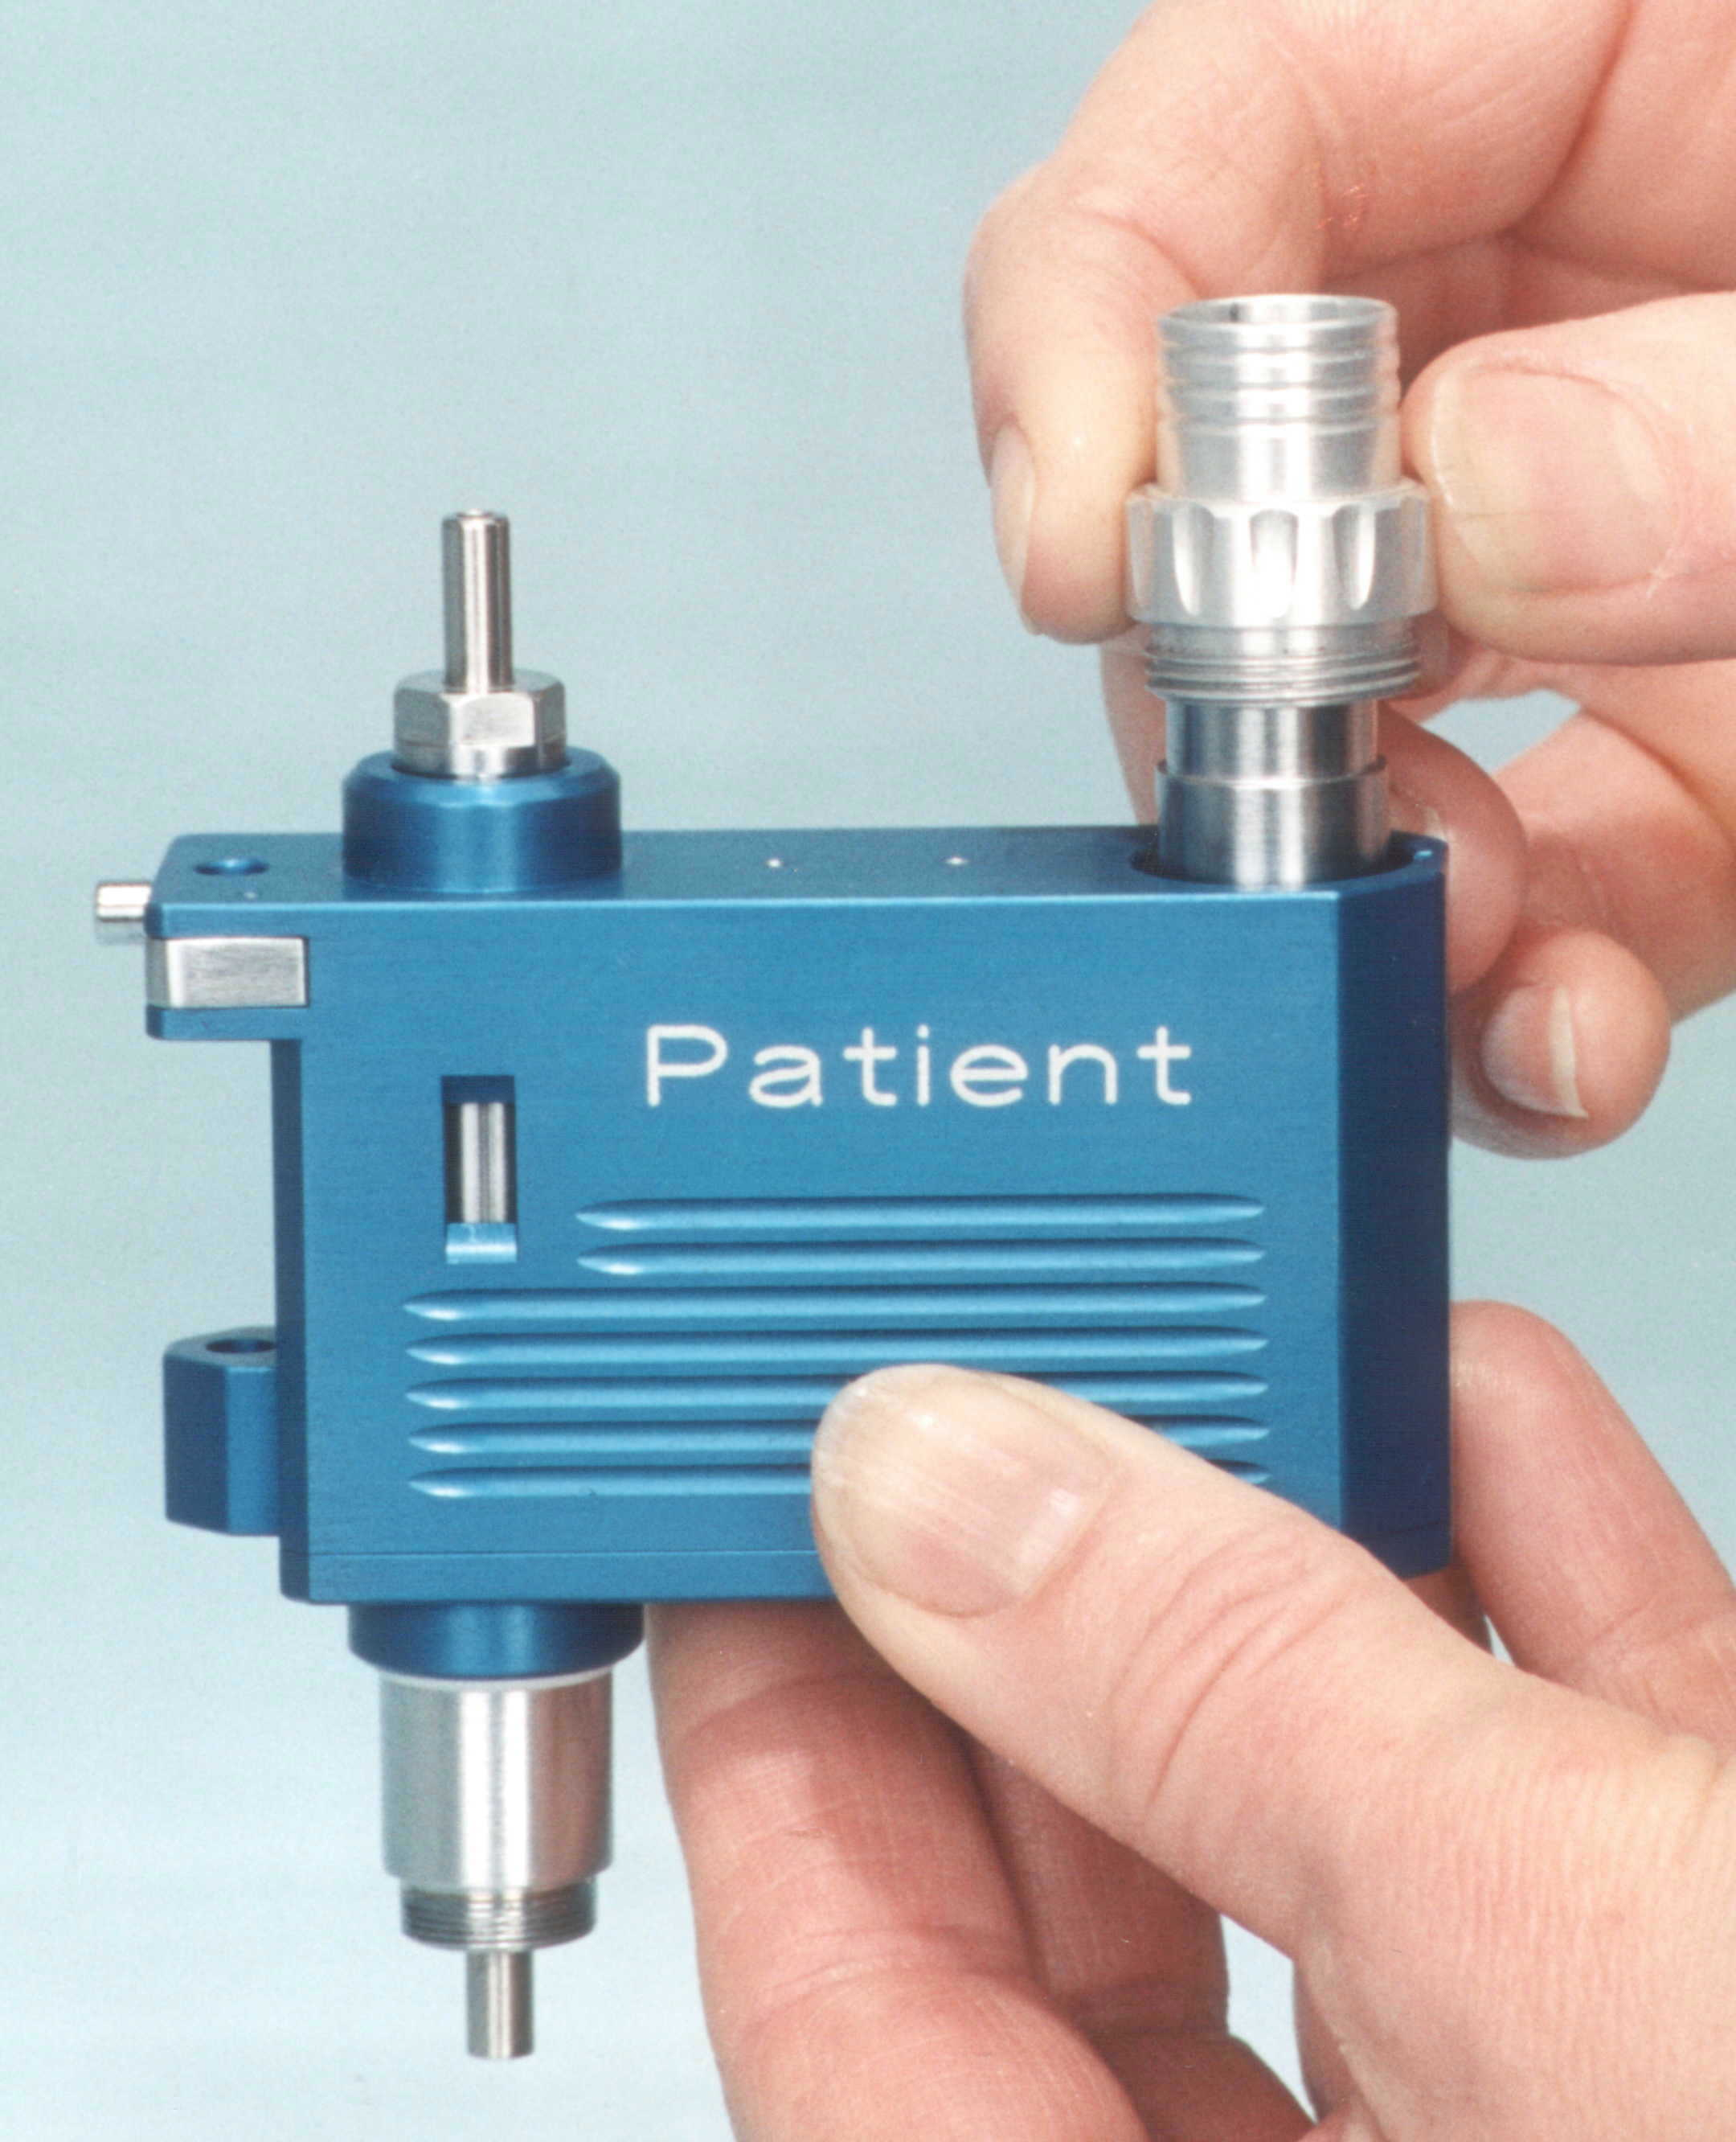
- Insert the motor cartridge (PATIENT = blue (30) or DONOR = green (33)) into the appropriate hand piece using a non-sterile assistant. Orient the guidance pin of the motor cartridge toward the groove in the hand piece. | - Screw motor cartridge securing nut (20/27) over the motor housing. Should the nut not catch, remove motor cartridge, turn its gear slightly and reinsert it. Do not use force!
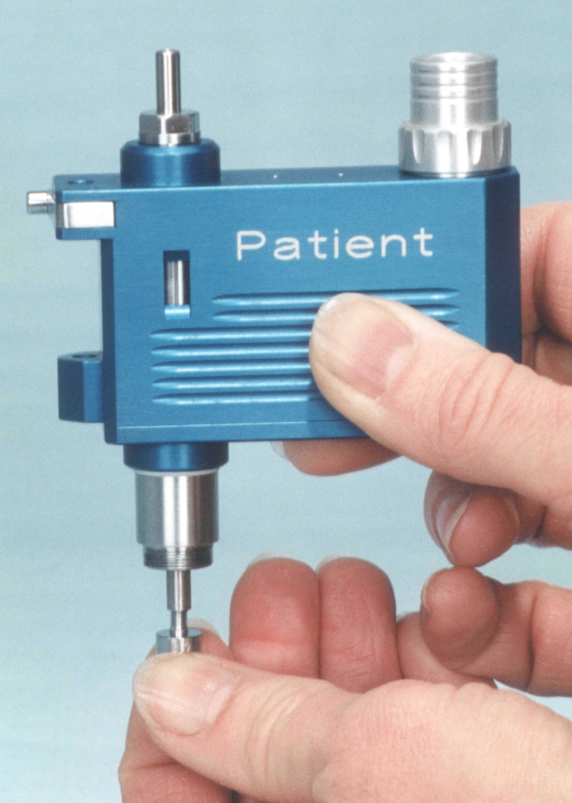 | PATIENT HANDPIECE ONLY  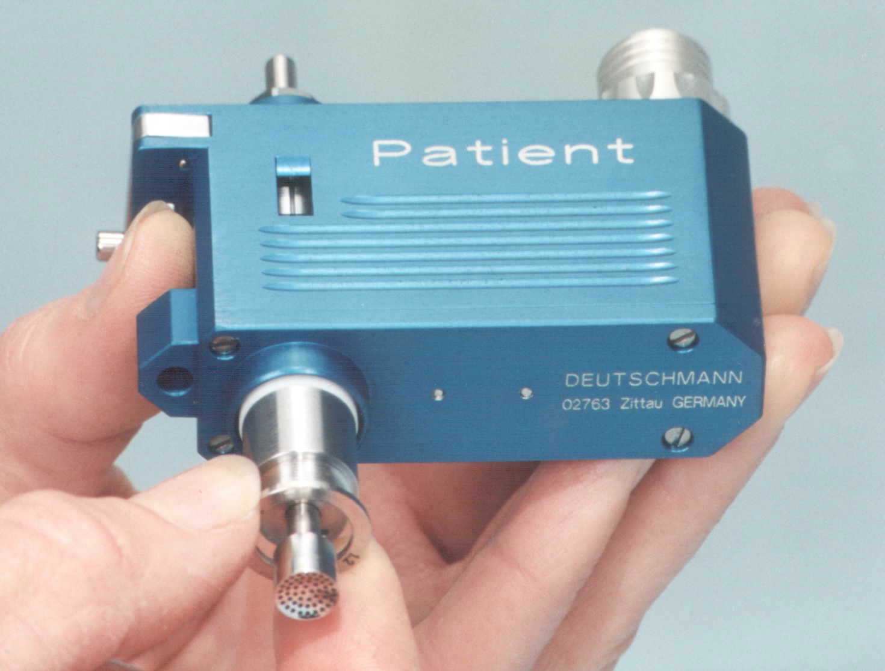
- Select the appropriate size central suction bell (17/24) corresponding to the chosen trephine diameter, and screw into the trephine axis, until it is firmly attached. Do not use force! | - Pick the desired offset ring and place it onto the trephine axis. Only use one ring at the time! Never use damaged or deformed offset rings!

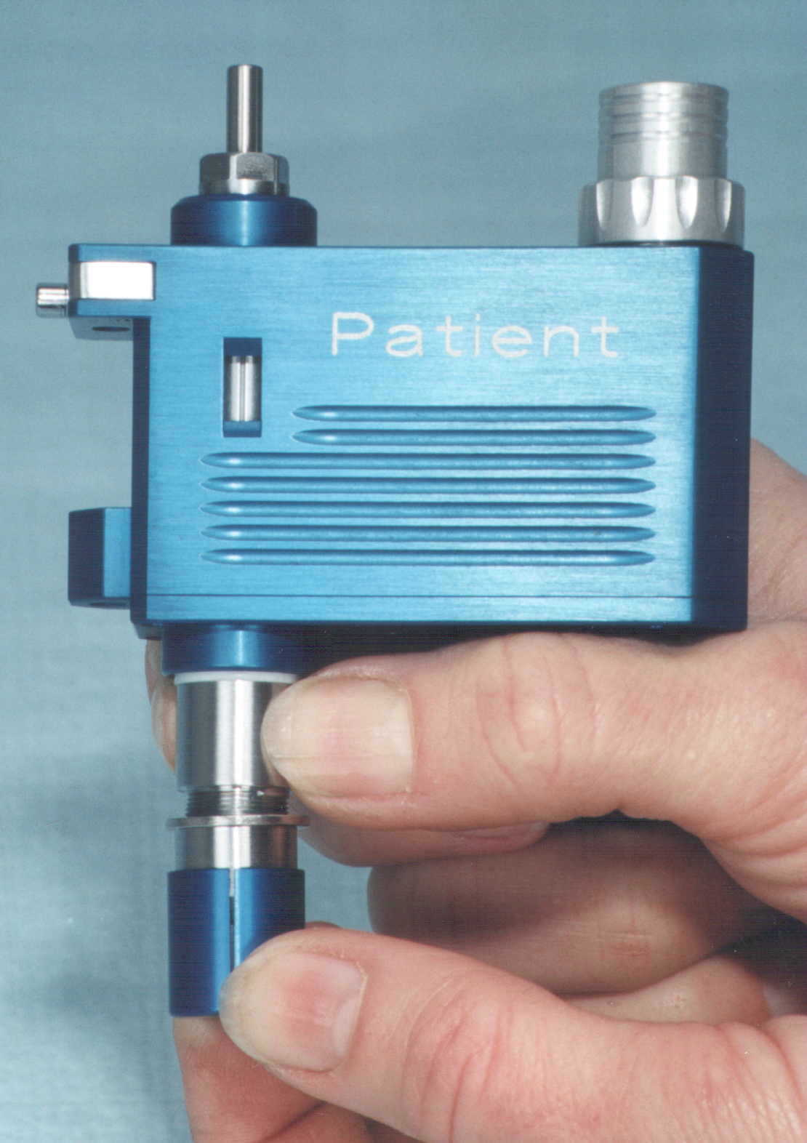 | 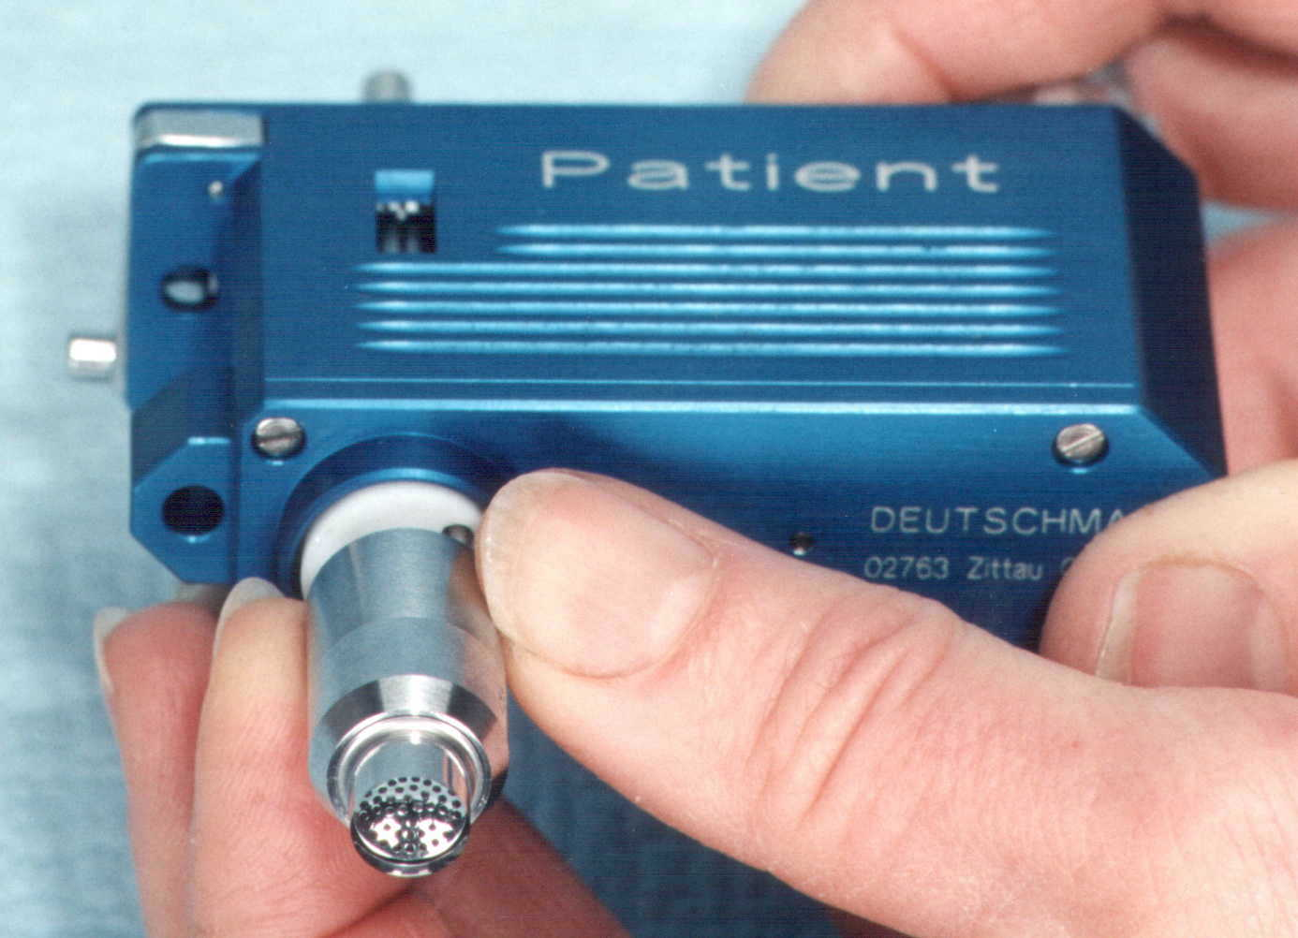
- Attach trephine cutter (16/23) with protection cap attached by screwing it onto the trephine axis (over the offset ring on the PATIENT hand piece, while holding it), until it is firmly attached, while gently holding the axis against rotation. Do not use force! | - Remove colored trephine protection cap carefully. Check the cutting edge of the trephine blade for damage. Push the blade slightly forward along the trephine axle to do so. Do not touch the blade! Never use damaged blades!
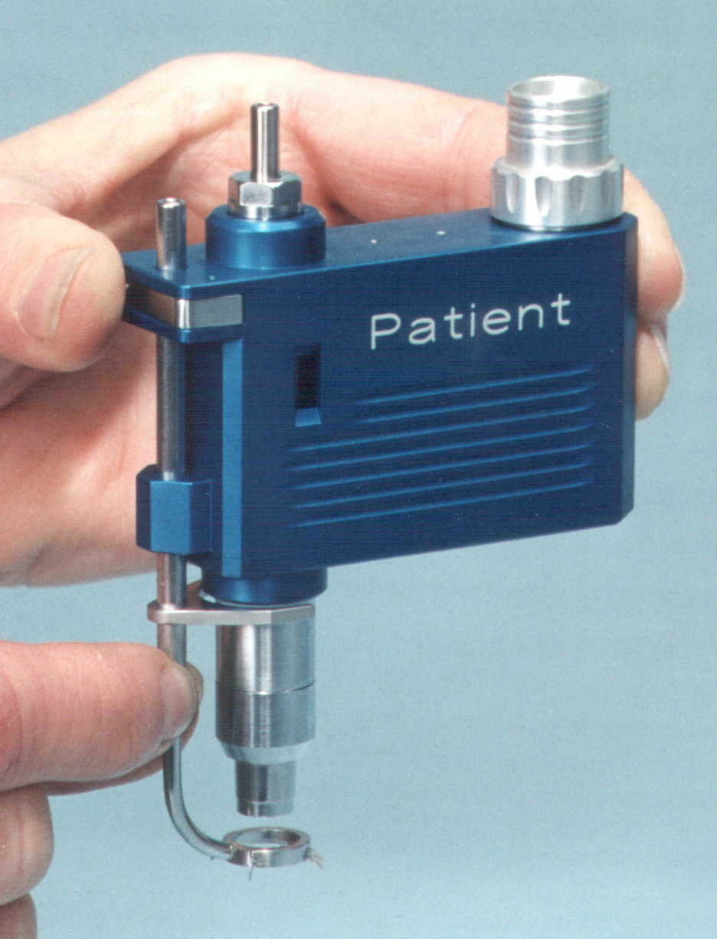 | 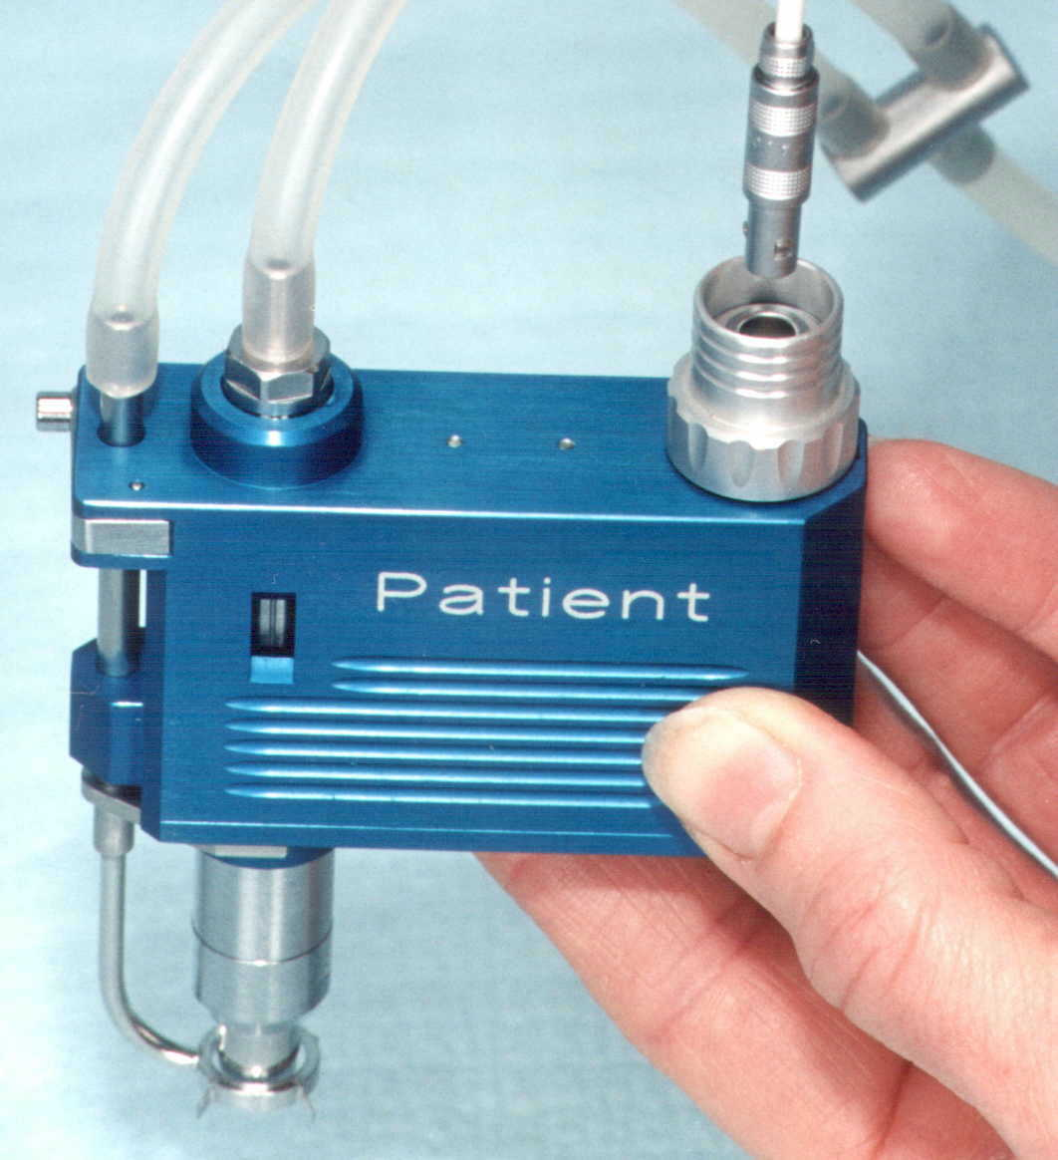
- Press the peripheral suction ring assembly lock release button on the hand piece (19/26) and slide in the peripheral suction ring assembly (18/25) all the way. Release the button and make sure assembly is locked. Use caution, not to touch the trephine blade! | - Connect the vacuum hose (28/31) to both vacuum flanges on the hand piece.  - Connect the motor cartridge power cable (29/32) to the motor cable.

Caution! Never hold the hand piece by the peripheral vacuum ring assembly or by the trephine blade. They are so delicate, that it could cause misalignment.

6. Initialization of the hand pieces

Warning! To assure a safe operation with the hand pieces, it is essential, that the blades are returned to their initial home positions before use. Neglecting to do so may cause injury to the patient and to the operator.
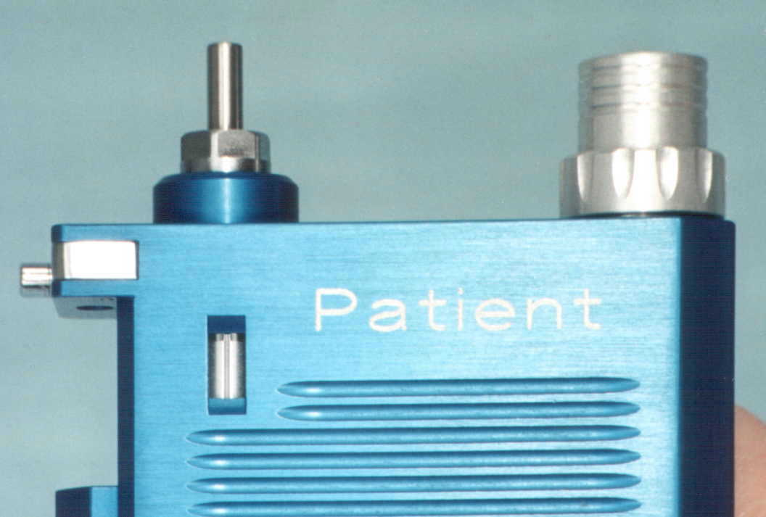
- Prepare the control unit for use (chapter 3.)
- Switch power on (2) – Power on indicator light (1) and a beeping sound should come on.
- Push the trephine blade feed homing switch (3) until the home marker (white line) appears in the hand piece’s homing window, and wait until the cutter retracts with a snap into the home position. Immediately release the homing switch. The hand piece is initialized.
- Switch of the main power switch.

7. Trephination

7.1 Trephination of the transplant from a corneo-scleral disc

- Prepare the control unit for use (chapter 4), prepare and assemble the DONOR hand piece (chapter 5).
- Initialize donor hand piece (26) as described in chapter 6.
- Switch power on (2) - tone will sound.
- Rinse the corneo-scleral disc on a sterile, firm surface with a BSS solution.
- Remove connective tissue residues from the cornea with a spatula.
- Hold donor hand piece with cutter facing up.
- Place corneo-scleral disc onto the peripheral suction ring and center it.
- Switch on vacuum switch (4) to fixate disc.
- When appropriate vacuum pressure is present, the beeping sound will stop.
- Activate foot switch (34). The trephine blade starts rotating and feeding.
- Release footswitch (34) once the trephine is finished and returned to its home position.
- Switch off vacuum switch (4). The vacuum pump will stop, the system will be automatically vented and the vacuum pressure will be released.
- Remove the transplant from central suction bell and store it in an appropriate solution.
- Turn off power switch (2).
- Remove the vacuum hose (31) and motor connection cable (32) from their connections on the DONOR hand piece and the control unit.
- In preparation for the trephination on the patient, plug in the PATIENT hand piece vacuum hose (28) and motor connection cable (32) into their connections on the control unit (8/6).

7.2 Trephination on the patient

Make sure the control unit and the PATIENT hand piece are prepared and assembled properly as described in chapters 4 and 5. Check the home position of the cutter feed on the hand piece (chapter #6) and perform a test run. Re-check home position again after the test run.

7.2.1. Preparation of the patient

- Determine the patient’s maximum corneal thickness using a pachimeter.
- Perform oculopression to reduce IOP and explosive perforation.
- Fixate the bulbus trough restraining the sup. and inf. med. rect. with sutures.
- In case of a flat anterior chamber, an incision should be made and viscoelastic should be injected to fill the anterior chamber.

7.2.2. Centering the trephine

The ASMOTOM MARKER was designed to help the centering process.

- Mark the center of the cornea.
- Press ASMOTOM MARKER on a stamp pad.
- Center the smaller circle of the MARKEUR around the center mark on the cornea and press slightly. The imprint of the outer and bigger circle is equivalent to the diameter of the peripheral suction ring.
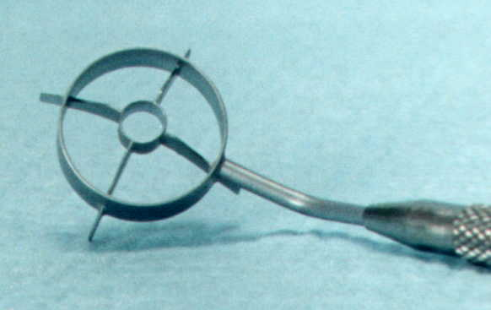
- Take the assembled PATIENT hand piece and position the peripheral suction ring to match the larger circle created with the MARKER.
- Successful centration of the hand piece can be verified by temporarily applying vacuum (control unit power on, vacuum switch on and after a few seconds off) and checking the imprint of the peripheral suction ring if it matches the initial marking.

7.2.3. Trephination of the patient cornea

- Make sure the PATIENT hand piece cutter feed is set to its home position (chapter 4).
- Switch main power switch (2). Beeping sound comes on.
- Center the hand piece.
- Switch on the vacuum switch (4) to activate suction.
- The cornea of the patient will be attached to the hand piece and fixated.
- Once a safe level of vacuum is built up, the beeping sound will stop. The patient’s bulbus should be lifted slightly.
- Never apply any pressure onto the bulbus during trephination.
- Verify with your assistant, looking from the side, if the hand piece is being held perfectly vertically.
- Activate footswitch (34). The cutter starts rotating and feeding into the cornea.
- When the anterior chamber is filled with viscoelastic, and the bulbus slightly lifted, the complete cutting cycle can be performed.
- Release footswitch (34) after automatic retraction of the blade.
- Switch off vacuum switch (4). The suction will be released.
- Remove separated cornea disc from the suction bell or from the patient’s eye, if still attached.
- Turn off main power switch (2).
8. Disassembly and preparation for cleaning and sterilization

After use, the ASMOTOM ATS has to be disassembled, in preparation for the cleaning, disinfecting, and sterilization process.

- Disconnect vacuum hose (28/31) from hand pieces and control unit (8).
- Disconnect hand piece power cable (29/32) from the motor cartridge connectors (30/33) and the control unit connector (6) by pulling on the connector’s locking ring.
- Unplug footswitch cord (34) from the footswitch connector on the control unit (7) the same way.
- Unscrew motor cartridge securing nut (20/27) and remove motor cartridge (30/33) from the hand piece.
- Remove Suction ring assembly by pushing the locking pin on the hand piece and sliding out the assembly. CAUTION! DO NOT TOUCH CUTTER!
- Carefully place colored cutter protection cap over the cutter and unscrew it from the trephine axis on the hand piece.
- Remove offset ring.
- Unscrew vacuum bell.
- Unscrew collector (10) from the liquid separator on the control unit. (9)

9. Cleaning and sterilization

For the cleaning we recommend using the “elma clean 10” cleaning solution in the concentration of 5% as recommended by ELMA. (See attachment A).

For ultrasonic cleaning we recommend using a model elma or similar ultrasonic cleaner from other manufactures, or a similar model with an ultrasonic frequency of 25- 45 kHz. A cycle time of 10 minutes, a temperature of 60 – 80° C. Fill bath with a 5% concentration of the cleaning solution.

The gear mechanism is designed to be maintenance and lubrication free trough the use of material combinations, which provide self lubrication.

- Only use cleaning products suitable for anodized aluminum!
- Never use any lubricant!

9.1 Motor cartridges for PATIENT and DONOR (30/33)

- Clean the surface of the motor cartridges with a damp cloth containing the cleaning solution.
- Wipe dry with a dry cloth.
- Place motor cartridges back in the motor storage box.
- Never immerse the motor cartridges into any liquid.
- Never clean motor cartridges in an ultrasound bath.
- Never sterilize motor cartridges using steam, hot air or gas or any other means.
- Never lubricate the driving gear at the end of the motor cartridge.

9.2. Hand pieces for PATIENT and DONOR (19/26)

- Rinse vacuum pipe with distilled water using 20 ml syringe.
- Clean the hand pieces with a damp cloth containing the cleaning solution.
- Wipe dry with a dry cloth.
- Place the hand pieces back into their place on the storage/sterilization trays.
- Never immerse the hand pieces into any liquid.
- Never clean hand pieces in an ultrasound bath.
- Never lubricate the gears of the hand pieces.

9.3. Trephine blades for PATIENT and DONOR (16/23)

- Make sure the protective cups are secure on the blade assemblies.
- Perform ultrasound-cleaning cycle.
- Rinse trephines with distilled water.
- Wipe the outside surfaces dry with a dry cloth.
- After the cleaning process check trephine blades for damage using a microscope.
- Place trephine blades back into their place on the storage/sterilization trays.
- Never clean trephines mechanically! It might damage the cutter.
- Never remove trephine protection cap for cleaning.
- NEVER USE DAMAGED TREPHINES!

9.4. Suction bell and suction ring for PATIENT and DONOR (17/18/24/25)

- Rinse vacuum pipe with distilled water using 20 ml syringe.
- Perform ultrasound-cleaning cycle.
- Rinse parts with distilled water.
- Wipe the outside surfaces dry with a dry cloth.
- Check parts for visible damage.
- Place parts back into their place on the storage/sterilization trays.
- Never clean suction bell and ring mechanically. It might damage them.
- Never use hard or sharp tools for cleaning such as a needle, cannula or scalpel.
- Make sure that neither the walls of the ultrasound bath nor other tools/instruments in the bath do damage the suction bell or ring while cleaning.

9.5. Offset rings – patient only (21)

- Perform ultrasound-cleaning cycle.
- Rinse offset ring with distilled water.
- Wipe the surfaces dry with a dry cloth.
- Check ring visible damage, especially for deformation and pits.
- Place ring back into its place on the storage/sterilization tray.
- NEVER USE DAMAGED OFFSET RINGS! THEY WILL INCREASE THE CUTTING DEPTH.

9.6. Vacuum hose (28/31)

- Wash vacuum under running water.
- Rinse vacuum hose using the cleaning solution.
- Rinse the inside by flushing trough 20 ml of distilled water.
- Drain out the remaining distilled water.
- Wipe outside dry with a dry cloth.
- Make sure not to overstress the hoses in order to avoid cracks and leaks.

9.7. Hand piece power cables (29/32)

- Clean the hand piece power cables (29/32) with a damp cloth containing the cleaning solution.
- Wipe dry with a dry cloth.
- Place the hand piece power cables back into their place on the storage/sterilization trays.
- Never immerse power cables into any liquid. It will destroy them.
- Avoid kinks and pinches to the cables, it will cause damage to them.

9.8. Liquid container (10)

- Empty container and wash under running water.
- Rinse container using the cleaning solution.
- Wipe dry with a dry cloth.
- Reinstall container on to the power unit.
- Make sure it is attached tight to avoid vacuum leak.
- Do not sterilize.

9.9 Sterilization

After all parts of the hand pieces, including the electrical cables and vacuum hoses are cleaned and put back in their place on the storage/sterilization trays, check if all components are present. Then load the trays back into the storage/sterilization cassette and latch.

Steam sterilization is recommended.

Place the storage/sterilization cassette into the chamber of a steam sterilizer. Run a sterilization cycle at 134 degrees Celsius for 45 minutes.

After completion of the sterilization cycle remove the cassette and store it in a dry place.

Contents will remain sterile until the cassette is opened.

All components of the hand pieces, including the electrical cables and vacuum hoses except for the motor cartridges have to be sterilized. Make sure they are all present before running the sterilization cycle!

10. Troubleshooting

IMPORTANT!

- Prior to any maintenance work unplug the power cord of the control unit!
- Repairs to the ASMOTOM and all it’s components should only be made by the manufacturer or authorized representatives. Tempering with the equipment will void the warranty.

 | Problem | Possible cause | Solution
01 | Control unit does not come on | Defective power cord | Replace power cord
 |  | Defective fuse | Replace fuse  If it fails repeatedly, send in for repair
 |  | Defective power supply | Send in for repair
02 | Vacuum pump inoperative | Defective fuse | Replace fuse
 |  | Defective vacuum pump | Send in for repair
03 | Leak in vacuum system | Damaged vacuum hose | Replace hose
 |  | Vacuum hose improperly connected to control unit or to hand piece | Check all vacuum hose connections
 |  | Hand piece not initialized Trephine blade is in front of peripheral suction ring preventing attachment to the cornea | Initialize hand piece, reset cutter feed to home position
 |  | Suction bell is not completely mounted | Screw in suction bell all the way
 |  | Deformed suction bell or suction ring | Replace suction bell or suction ring
 |  | Separation container is not attached properly | Screw in container completely
04 | Hand piece motor inoperative | Motor cable and/or footswitch are not connected properly | Check connections and reconnect motor cable and footswitch
 |  | Defective motor cable or cable connection | Exchange cable
 |  | Defective motor | Exchange motor
 |  | Safety vacuum switch disables power to motor | Troubleshoot vacuum system
 |  | Defective footswitch or connector | Replace footswitch

11. Technical data

Control unit:

Power supply: Automatic 90 – 240 V ~ / max. 2.0 A / 50 – 60 Hz
Protection Class: I
Protection Type: XO
Duration: max. 3 hours
Max Vacuum: -800 mbar
Min. op vacuum: -500 mbar
Dimensions: 365 x 115 x 315 mm (L x H x D)
Weight: Approx. 5.0 kg

Footswitch:

Connection: 12 V -
Protection: X8

Hand piece | PATIENT | DONOR
Motor | 12 V | 12 V
Idle speed | 16,500 RPM | 16,500 RPM
Cutting depth | 0 – without offset ring | 1.7 mm
Offset rings | .2, .4, .6, .8, .9, 1.0, 1.1, 1.2 mm | None
Weight assembled | ~ 200 g | ~ 200 g
Cutter sizes | 2 x 6.0 mm | 2 x 6.0 mm
 | 2 x 6.5 mm | 2 x 6.5 mm
 | 2 x 7.0 mm | 2 x 7.1 mm
 | 2 x 7.5 mm | 2 x 7.6 mm
 | 2 x 8.0 mm | 2 x 8.2 mm
Suction bell sizes | Same as cutter sizes | Same as cutter sizes
Suction ring | 12.0 mm OD, 4 radial markings | 12.0 mm OD, no markings

12. Maintenance of the ASMOTOM ATS

In order to assure a reliable and trouble free operation of the ASMOTOM, the following maintenance should be performed on a regular basis.

Trephine

The quality of the trephination largely influences the outcome of the entire transplantation procedure. For this reason it is especially important, that the cutters be treated with care and periodically be sent back to the manufacturer for examination and re-sharpening.

In case of routine use, the blades have to be sent back for reconditioning after every 15 to 20 procedures. Damaged trephine blades may never be used, because they could cause severe injury to the patient.

Offset rings

Check offset rings for deformation and other potential damage after each procedure. Deformed, bent or damaged offset rings may never be used, since they could cause an increase in cutting depth leading to potentially severe injury of the patient.

Scheduled factory inspections

To maintain a safe operation of the ASMOTOM ATS, the complete ASMOTOM ATS with all its accessories should be sent back to the factory for a general inspection after 50 surgical procedures.

Attachment A:

Elma clean 10

Universal cleaning concentrate
Liquid alkaline cleaner
Highly economical; environment-friendly; biodegradable

Description

Suitable for the thorough cleaning of instruments and equipment made of glass, plastics, ceramics, steel. Particularly suitable for medical and dental instruments and laboratory equipment. Cleans also crowns, stainless-steel dental impression trays, etc.

Attention: Not suitable for aluminium, zinc or light alloys. Good for use in an ultrasonic bath.
Application: Removes blood, saliva, protein, bones; fats, oil, grinding and polishing paste.

Registered at the Umweltbundesamt (Federal Environment Authority) under
UBA No.: 1240 0001.

Application and dosage

Dosage: 5% dilution, a higher concentration might be required for stronger contamination.
Cleans best at a temperature of 50 – 80°C, (remove proteins and blood in cold solution
to prevent coagulation).

Cleaning time: 4 – 10 min. in ultrasonic bath,
15 – 30 min. without ultrasound
After cleaning, rinse under running water.

Safety warnings

Handle chemicals with care. Observe the R- and S-phrases: R 34: Causes burns. S 1/2: Keep locked up and out of the reach of children. S 26: In case of contact with eyes, rinse immediately with plenty of water and seek medical advice. S 28.1: After contact with skin, wash immediately with plenty of water. S 36/37/39: Wear suitable protective clothing, gloves and eye/face protection. S 46: If swallowed, seek medical advice immediately and show container or label. Corrosive (C).

Physico-chemical facts:

Density: 1045 g/l; pH 12.35 in original state.

Disposal

The organic detergents are easily biodegradable according to the OECD test.
The chemical can be fed into the sewage system after use; observe local pH limit values and check the contamination contained in the used chemical. (Observe local sewage regulations).
Recommendation: use acetic acid or citric acid for neutralisation.

Volumes and storage

Store in original container only. Do not store together with acids. Available volumes:
1l, 5l, 10l and 25l. Shelf life: 5 years from date of production (see label).
The chemical falls under the dangerous goods regulations: class 8, UN: 1824.

Elma clean products are available in the US from:

LAB - LINE INSTRUMENTS INC.
One Lab - Line Plaza
Melrose Park, IL 60160 USA
Tel.: + 1 708 450 2600
Fax: + 1 708 450 2656

